**PYTHON**

**BY**

**Mr. YUKTESH**

**Yuvan Technologies**

**Flat no – 347, 1st Floor, HMT Hills, Near HMT Community Hall, Beside Park, JNTU Opp Road, Hyderabad - 500072**

**Contact: 8297 929 550, 9381 860 858**

**Basic Python:**

* Introduction to Python
* Writing our First Python Program
* Variables and Data types
* String Handling in Python
* Operators
* Input and Output
* Control Statements
* Collections
* Functions
* Modules and Packages

**Advance Python:**

* Oops
* Abstract classes and Interfaces
* Exception Handling
* Files in Python
* Threads
* Regular Expressions
* Python Database Connectivity
* Networking in Python
* Data and Time
* OS and SYS
* Graphical User Interface
* Data Science using Python
* Introduction to Django Framework.

**Introduction to Python:**

Python is a general purpose, high level, interpreted and object oriented scripting language.

This is not compiler language like c, c++

**Why people are learning Python:**

For beginner’s python is the best language to learn and it supports wide range of applications from simple text processing to worldwide web browsers to games

**Who Introduced Python:**

Guido Van Rossum who developed Python in the year 1989 at CWI (Centrum Wiskunde & Informatics) in the Netherlands and he first released to public in 1991.

**Uses of Python:**

Python is used in developing wide range of applications.

1. Web development
2. Scientific and Numeric computing
3. Data Analytics
4. Automation applications
5. System level applications
6. Network with IoT applications
7. Gaming Applications
8. Software Testing Applications
9. Animation applications and so on

F**eatures of Python:**

1. Simple: Python is a simple programming languages, It uses English like sentences in the programs which helps programmers understand easily
2. Easy to Learn: Python uses very few keywords. Its programs are very simple in structure
3. Open Source: Python can be freely downloaded from its official website [www.python.org](http://www.python.org) its source code can read, modified and can be used in programs as desired by the programmers
4. High Level Language: High level languages are human easy understandable i.e., it uses English words in the programs hence it is called High level language
5. Dynamically Typed: In python, we need not declare variables. Depending on the values stored in the variable, Python interpreter internally assumes the datatype.
6. Platform Independent: Python programs are not dependent on any computer and any Operating System. A python program written in windows operating system will execute in Linux and mac operating systems also. We can install python on Unix, Linux, Windows, Macintosh, Solaris etc.
7. Portable: When a program gives same results in any operating system in this world. Then it is called portable program. Python programs are portable programs as they give same result across as platforms
8. Procedure and Object oriented: Python is both procedure oriented and object oriented language. In pols the program are build using functions and oopl’s programs are built using class and objects.
9. Interpreted: Python is a interpreted language as instructions in the program as executed line by line.

10.Scripting Language: A Scripting language uses an interpreter to translate the source code into machine code on the fly(while running)

11. Database Connectivity: A database represents that stores and manipulates data. Python provides interface to connect its programs to all major databases like DB2, Oracle, Sybase, SQL Server or Mysql

12. Scalable: A program is scalable if it can move to another OS or Hardware and take full advantage of the new environment in terms of performance

13. Batteries included: The Huge library of Python contains several small applications (or small packages) which are already developed and immediately available to programmers. These libraries are called ‘Batteries Include’

To know the entire list of packages included in Python, you can visit

[www.pythonanywhere.com/batteries_included/](http://www.pythonanywhere.com/batteries_included/)

**Organizations using Python:**

* Google: Google search engine developed using Python
* Facebook: It uses for its front development
* NASA (Scipy) They are using this for the best precession
* Walt Disney – They are using python scripts to facilitate moving images and data in & out of sequence
* Philips – Semiconductor development
* Redhat – They developed their installer using python
* National Weather Service – They use python in their system which helps in generating maps, weather forecasts etc.
* Dropbox – Using python in hosting files
* Youtube – For streaming they use python.

Note: Currently copy writes of the python language are registered with an Open community and non-profitable organization called “Python Software Foundation”

* Python software which is provided by the PSF is known as CPYTHON
* CPYTHON language is developed by using c language.
* CPYTHON language and source code are open source.
* Using CPYTHON many people developed their own python software according to their business requirement which is called Distribution.

**Distributions of Python:**

There are so many distributions are available for the CPYTHON. Some of them are

- **AnacondaPython**: For handling very large scale data ex: big data

- **Ironpython:** To support .Net framework this is written in c#. Here python program when compiled gives intermediate language(IL) which runs on Common Language Runtime(CLR) to produce the output.

- **Pypy**: Here JIT (Just in Time) compiler added to PVM of this Python distribution which helps in executing python program very fast

- **Jython**: This is earlier known as JPython. It is designed to run python programs by JVM

**Download and Install Python:**

We can install python from their official website python.org or google ‘python software’.

Steps to download and install Python software in our computer

**Step1:** Go to python.org or type ‘python software download’ in google and select the python.org link from the result.

**Step2:** Select Download and select respective Operating system

**Step3:** Depending up on operating system configuration either 32 or 64 select the respective executable installer and download

**Step4:** Open the downloaded .exe file check the Add python 3.6.4 to path checkbox and click on ‘Install Now’ and complete installation.

**Python software Installation:**

Step1: Search for “Python software download” in google

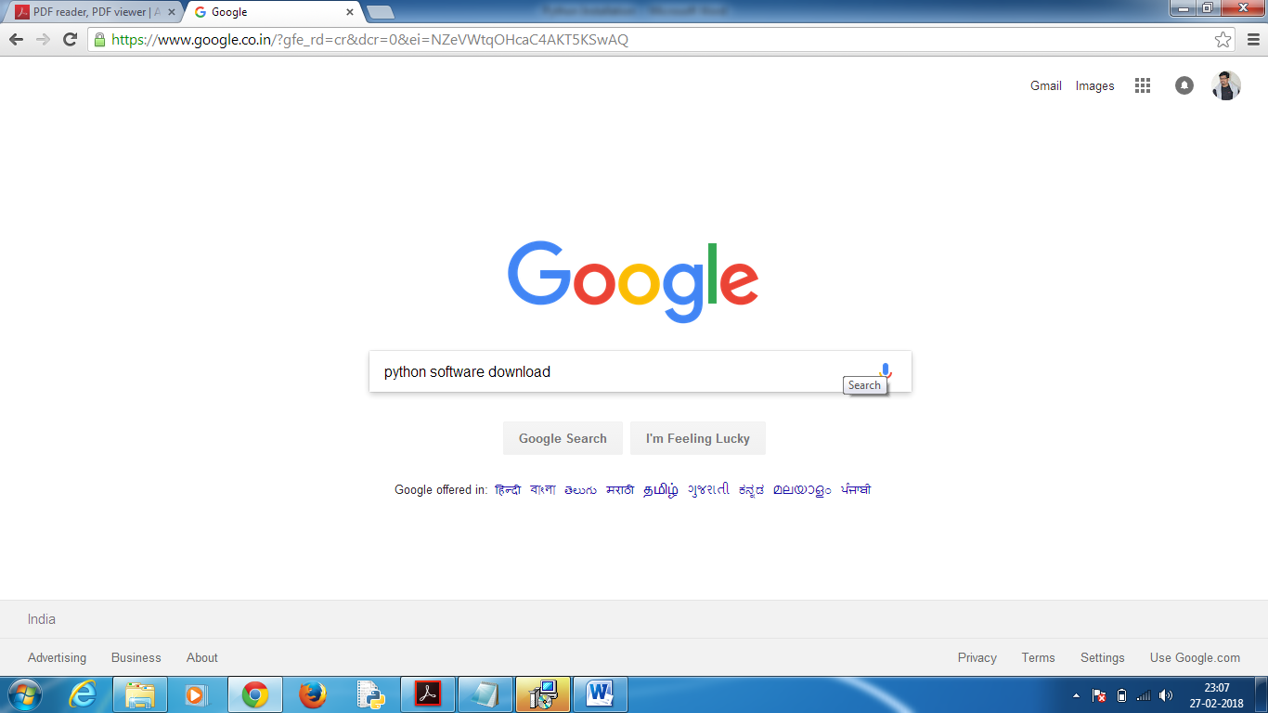

Step2: Click on Python.org link you will be landing on below page

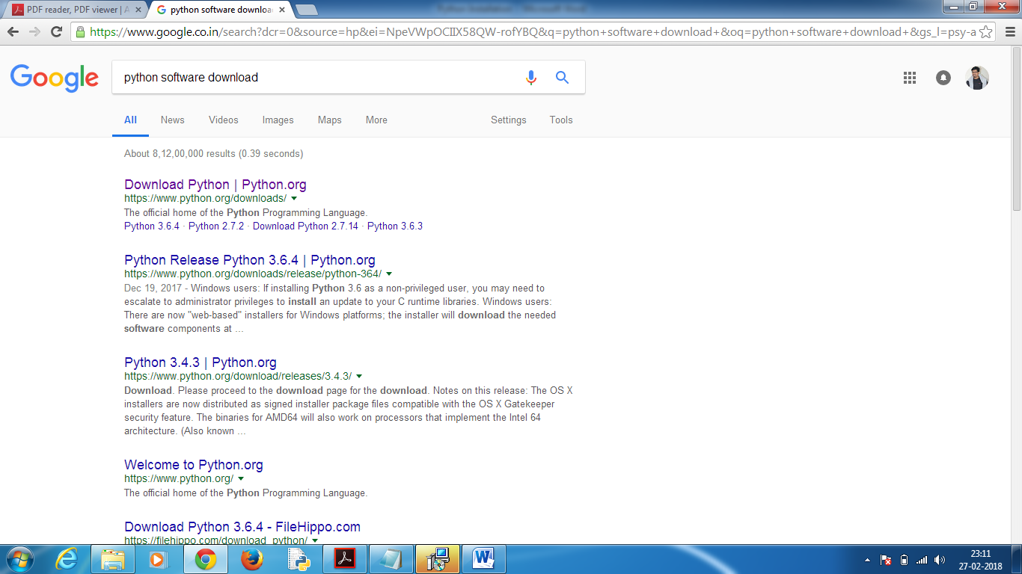

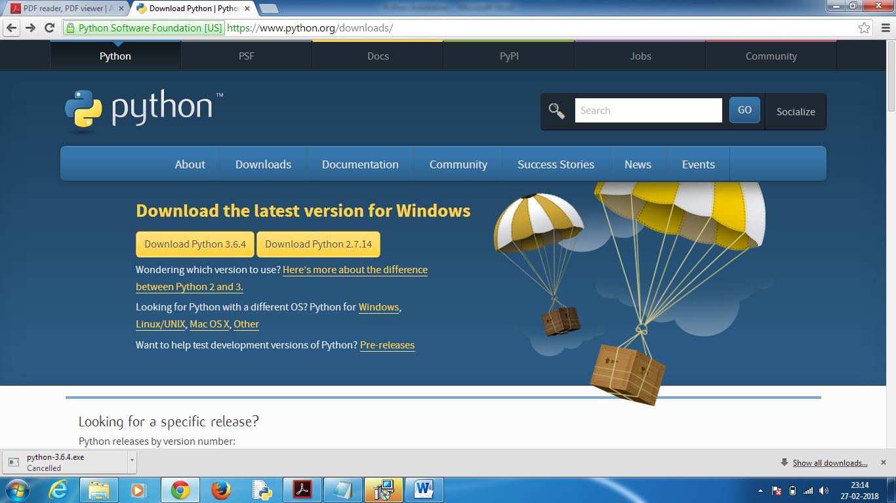

Step3: Go to Downloads and click on Windows.

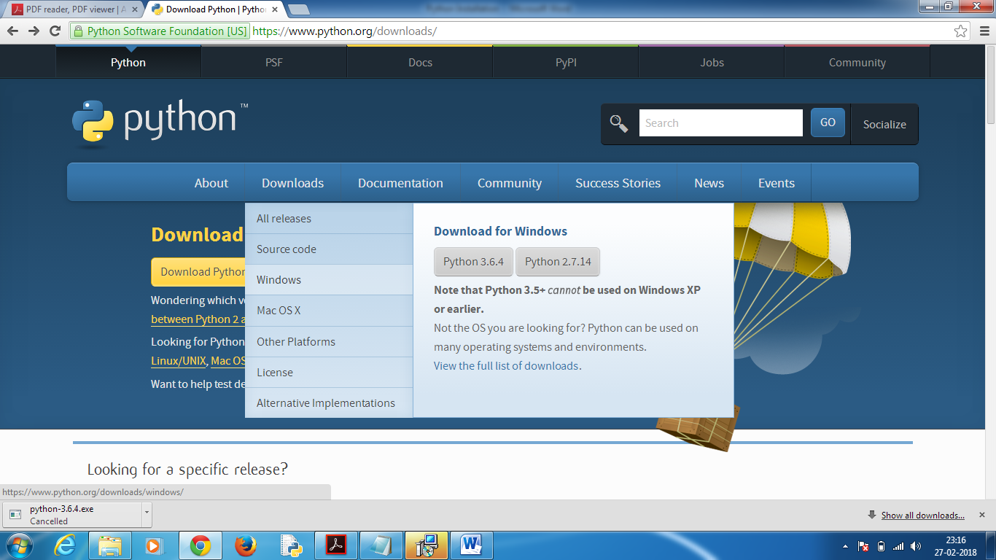

Step4: Click on Download “[Windows x86-64 executable installer](https://www.python.org/ftp/python/3.7.0/python-3.7.0b1-amd64.exe)” in below screen

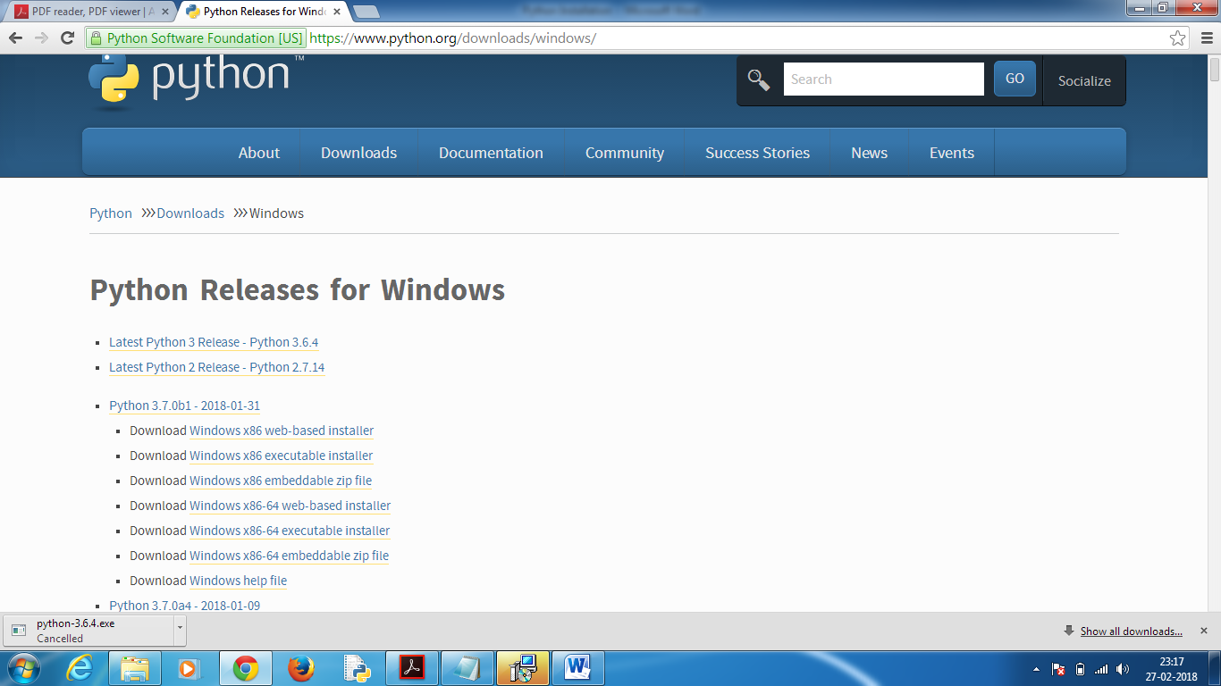

Step5: Double click on the below file

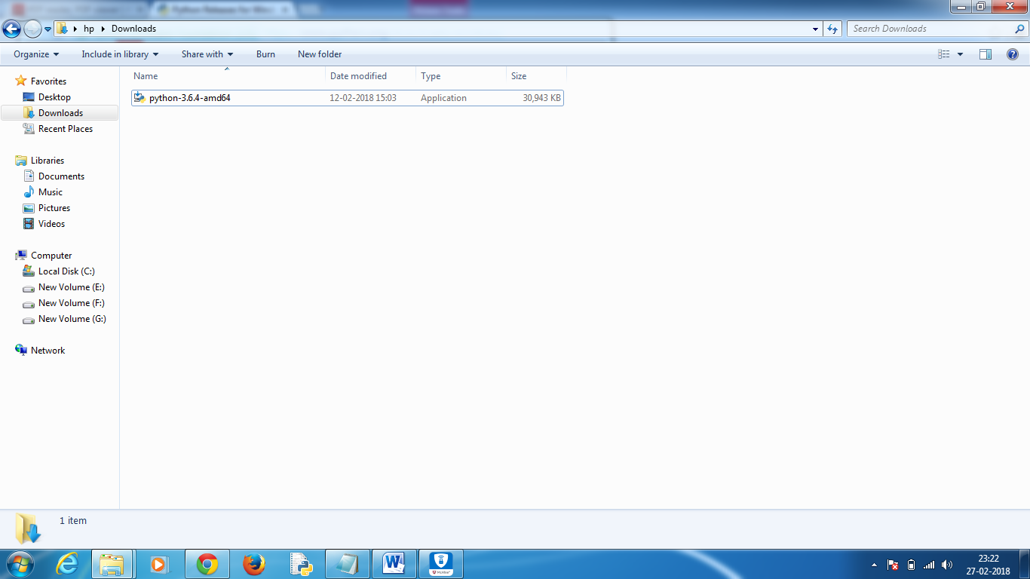

Step6: Click on Run

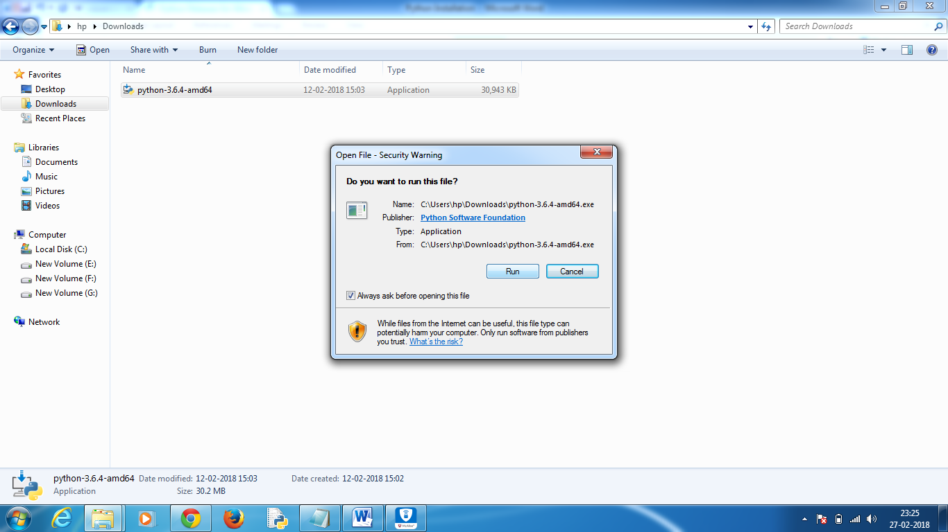

Step7: Check the box and click on Install Now

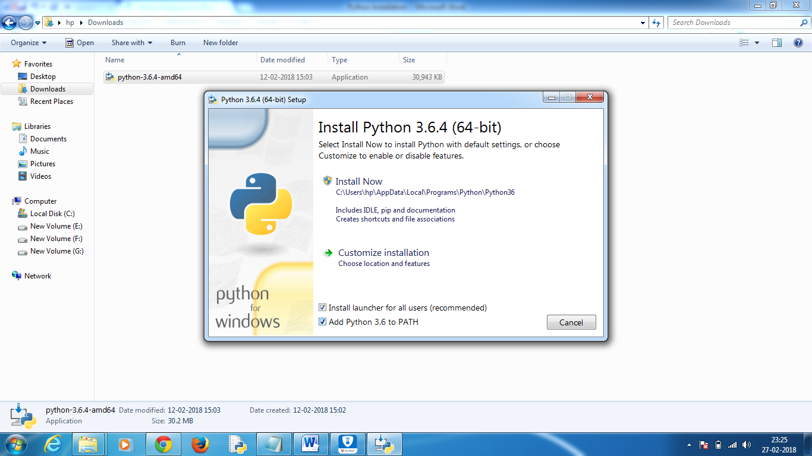

Step8: Complete all other steps and click on close



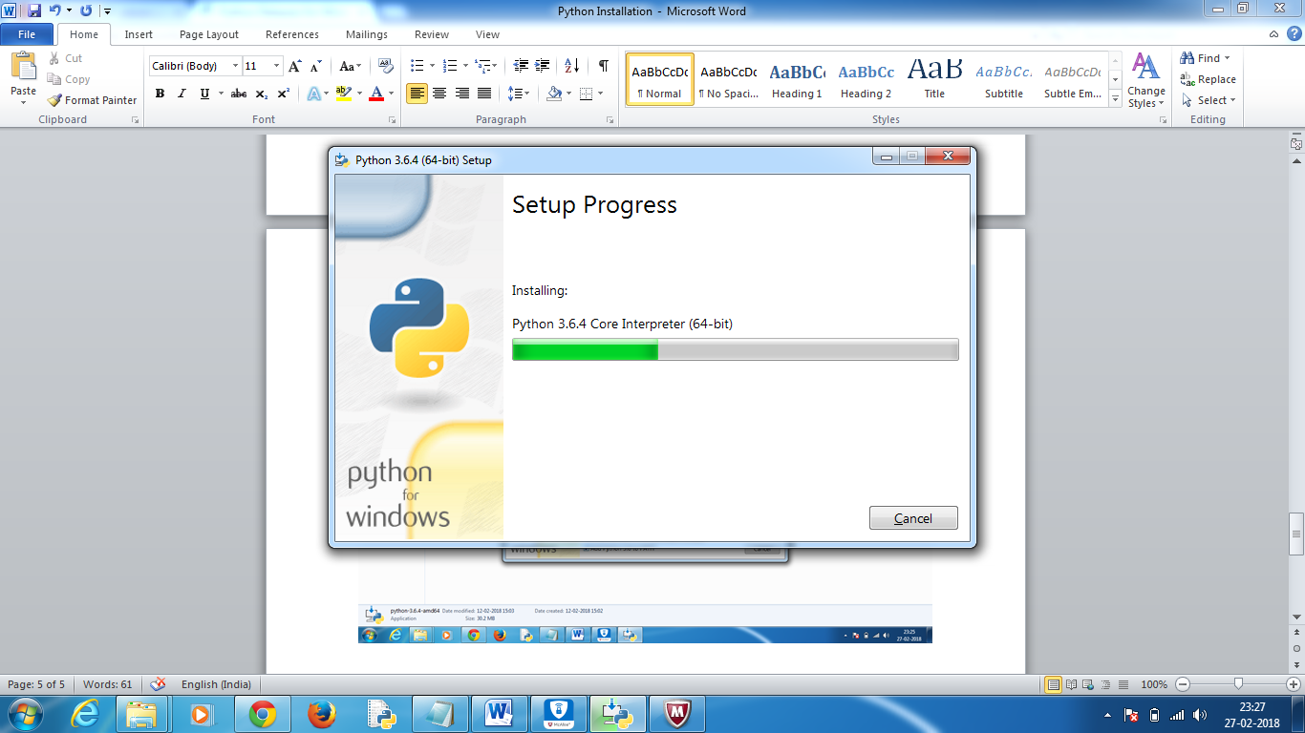

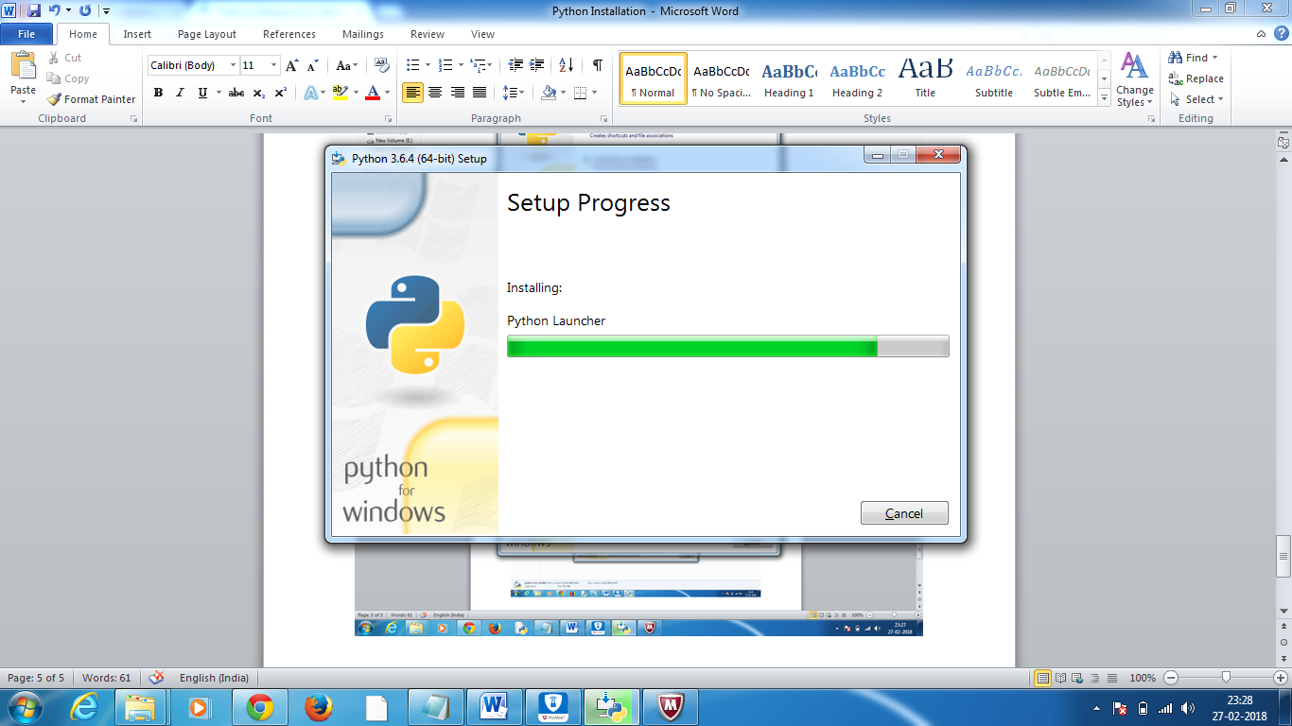

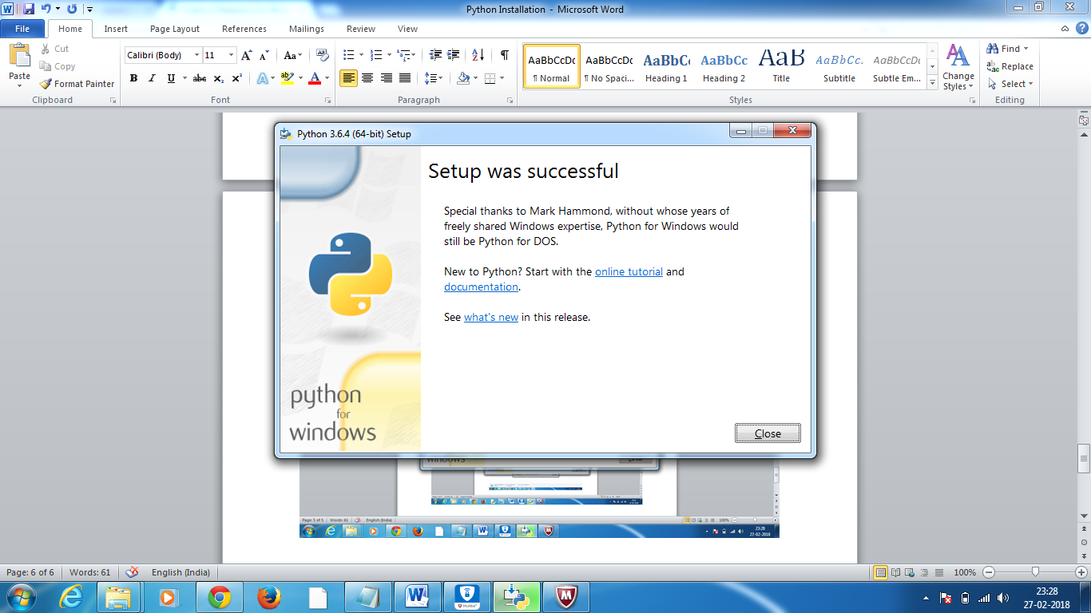

**Verify the Installation of Python:**

Go to start menu search for Python you should be able to see following

1. Python Manuals – These are help files. Here mostly we check below 3 things
2. Python Language Reference
3. The Python Standard Library
4. The Python Tutorials
5. Python IDLE (Interface Development Environment)
6. Python command prompt
7. Python Module Docs

**Python Programming Basics:**

There are two ways in which we can develop python programming.

1. Interactive Mode
2. Batch/Script Mode

In Interactive Mode code gets submit line by line to python interpreter. We develop this programming use Python command line shell. This we use for testing the python keywords.

In Batch Mode, we develop python statements in a file with .py extensions. Here at a time .py extension file is submitted to Python interpreter. We develop this type of programming by using Editors and IDEs.

**Writing our First Python Program**

We can write python program and execute in 3 ways

1. Python Command Line Shell
2. Python IDLE.
3. In a file with extension .py and execute from system prompt.

Type1:

* Click on python prompt from the start menu or go to command prompt and type ‘python’ we will land in python command line shell.
* Here just write print(“My First Python Program”) and click on enter immediately it get executes and displays result there only.

Type2:

* Click on IDLE icon from the start menu to open python GUI window
* Here just write print(“My First Python Program”) and click on enter immediately it get executes and displays result there only.

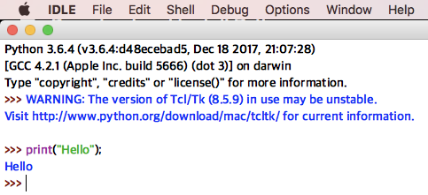

* From IDLE go to File->NewFile you can see a new window got opened where you can write Python program and save it with .py extension and save it your computer directory.
* To execute, Click on Run module from Run in the menu bar. You can see result in IDLE

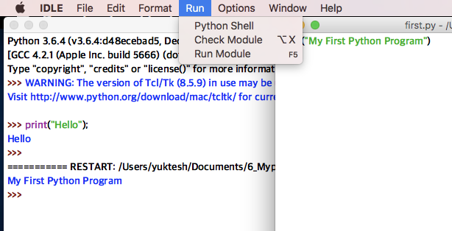

Type3:

* Here write program in a notepad file and save it with .py extension
* Go to command prompt go to the program directory and execute the program by typing Python filename.py and enter, you can see result in cmd there only.

Program2: second python program in all 3 ways

A=100

B=50

C=A+B

Print(“The Sum is:”,C)

Program3:

Write a Python program to find addition, subtraction, multiplication and division in all 3 ways.

A=100

B=50

print(“ Addition is:”,A+B)

print(“ Difference is:”,A-B)

print(“Product is:”,A*B)

print(“Division is:”,A/B)

**Getting Help in Python:**

We can understand the specific concept or feature or topic in python through help.

To go to help type help() function form python command line shell

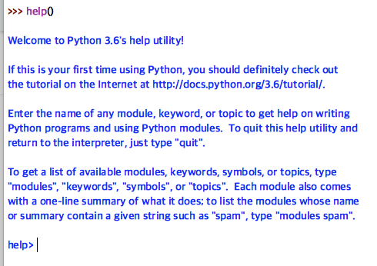

Module: It is a python program contains classes, functions, variables, constants, etc

Ex: sys, abc, tkinter,

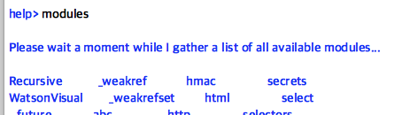

Package: A package contains several modules

Ex: Numpy, matplotlib, pandas

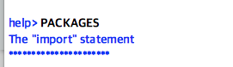

Note: Generally, packages would be developed by third party people

To know about Topics in python type topic in help

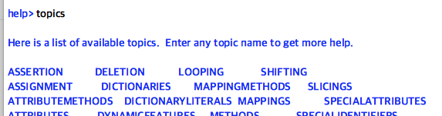

Out of these topics if I want to know about Functions. Type it in capital letters FUNCTIONS

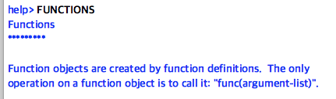

To know about print function

We can use help() in below fashion also

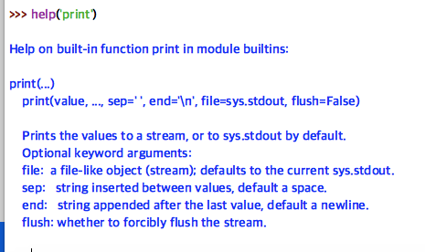

To quit help mode, we should just press Enter

To exit the Python IDLE Window, you can type either exit() or quit().

**Different Editors & IDEs:**

Editor: It is the place where we code our program.

Ex: Notepad, Notepad+, Editplus, VB

Program4:

Write a Python program to find sum of two numbers in Editor to understand limitations of Editor

In notepad: sum.py

A=100

B=50

C=a+b

Print(“Sum of two numbers is”,C)

C:\Python sum.py

150

**Disadvantages of Editors:**

1. Every statement in Editor we should write manually
2. After development python file, we need to perform debugging operations manually
3. Code generation tools cannot be used to generate our python programs

To Overcome the above problems, we develop the python files in batch mode by using IDE’s

Different type of Application development need different types of IDE’s developed. Find below some IDE’s

1. Pycharm
2. Eric
3. Eclipse
4. Myeclipse
5. Netbeans
6. Jupiter Notebook

Out of all above IDEs Pycharm is the best IDE to work on python applications. Many developers prefer working in Pycharm IDE as it is designed for python program development only.

Pycharm IDE comes off with 2 editions

1. Community Edition 2. Professional Edition

Using Pycharm community edition we can build normal and scientific applications using python. This is free

Using Pycharm professional edition we can build python web applications. This is not free, we can register for trial for 1 month only.

These days every software industry is trying to develop their own IDEs.

Python Web Frameworks:

A web framework is a code library that makes a developer's life easier when building reliable, scalable and maintainable web applications.

Following are the different python Web framework

1. Django 2. Flask 3. Cherrypy 4. Bottle

**Variables and Data Types in Python:**

**Scenario of a Project:**

Data (cname,cno,caddr,cbal

Cust---

Operations(withdraw(), transfer(),balenq())

Bank --

Data(Ename, Eadress,Eid,Esalary)

Emp---

Operations(DA(), HRA(),Tax(),Tsal())

Any Project we discuss we need to deal with data and operations. This we can implement in any language.

C, C++, Java, .Net and Python

Implementation in C: data type, variables and functions

Implementation in Java: data types, variables, class and object and methods

Implementation in Python: data type, variable, functions, class, objects and methods

**Variables in Python:**

A named memory location, to store temporary data with in a program. Variable value may vary through the program

* Variable store in primary memory or RAM or primary memory

In our computer, we have 2 types of memories

1. Primary memory - RAM
2. Secondary memory – Hard disk drive, Pendrive

In many languages

a=1

|  |
| --- |
| 10 |

A

a=2

|  |
| --- |
| 20 |

A

When you change A value to 2 new value will store into same box

Int b=a;

|  |  |
| --- | --- |
| 20 | 20 |

B A

A new memory box got created by the name b and the value of a is stored same in b.

This is how it works in other languages like c, java. But in Python it treats variables as just tag(as name) that is tied to some value.

For ex: a=1

a🡪1

Python considers the value 1 or 2 as objects. If we change value 1 to another new value then the tag is simply changed to new value.

Imp: Now value 1 become unreferenced object. It is removed by garbage collector

a=2

a🡪2 1 (This is removed by GC)

b=a

a

2

b

Here 1 memory referencing with 2 names a, b this is how python variable uses memory efficiently.

(a)Assigning Values to a Variable: We can assign any data type values to variables in the program

Ex:1

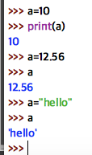

even if you give direct variable name ‘a’ it will work like print(a)

(b)Verifying data type of variable:

To know type of data of a variable we have type(). Just pass variable to type() as parameter.type()

syn: type(var)

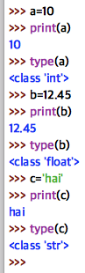

(C) Multiple Assignment: In python it is possible, In a single statement we can create multiple variable and assign their values

Ex:

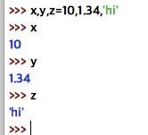

(D) Delete a Variable: We can delete a variable using del(). After delete if we try to print() it will show error

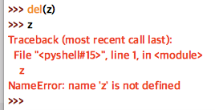

**Data Types in Python:**

Datatype -> Represents the type of data stored into a variable or memory. The data types which are already available in python are called Built-in data types and the programmers created data types are called user-defined data types

Implicit Declaration of Data Types in Python:

In python, we do not declare variable with any data type. This means even though we do not declare data type python compiler will give it dynamically based on the value assigned to that variable. In languages like C, Java this concept will not work over there we declare data types explicitly.

This implicit declaration is supported by PERL, VBScript and Python languages

In Python, Data types are broadly categorized into two types.

1. Fundamental Types
2. Collection Types

Following are the fundamental types in Python

1. Int
2. Float
3. Complex
4. Bool
5. String

int Datatype: Here we can store any integer i.e., either positive or negative numbers without any fraction part.

Ex1:

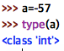

float Datatype: Here we store number with decimal part or fraction part.

Ex2:

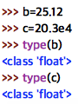

Here e represents exponential e4 =10power4

Complex Datatype: A complex number is a number that is written in a+bj format

Ex3: 5+3i

in above ex: 5 is real part

3i is called imaginary part

In python when you write complex number please use ‘j’ instead of ‘i’

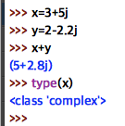

bool Datatype: bool type represents Boolean values. There are only 2 Boolean values we have True and False that can be represented using this type.

Ex4:

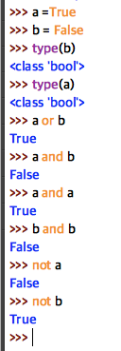

Str Datatype: Here str refers to string type of data. A string is represented in group of characters

Ex5:

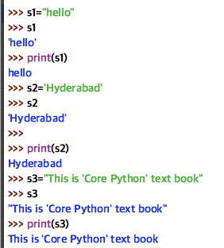

DocString:

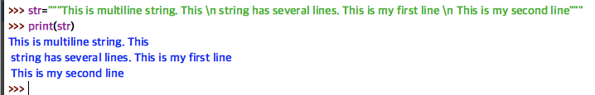

Finding length of String:

We have len() function to find length of a string. Pass string name as parameter to it.

Ex6:

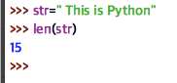

String Concatenation:

Adding two strings is nothing but string concatenation. We can do this with the help of + operator

Ex:7

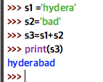

There are 3 important operations can we perform on all Collection types.

1. Indexing -> Referencing element from particular position.

Ex8:

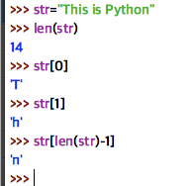

1. Slicing -> Retrieving a piece from a string

Ex9:

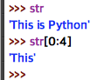

[0:4] means 4th character excluded. It will bring only 0,1,2,3

01234567891011121314

THIS IS PYTHON

-13,-12,-11,-10,-9,-8,-7,-6,-5,-4,-3,-2,-1

Ex:10

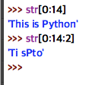

[0:14:2] it means 14th character excluded. It will bring 0,1,2,3,…13 and step size is 2 therefore it will bring alternative characters. It means 0,2,4,6,8,10,12

* [0:14:1] is same as [0:14]

Printing Reverse of a String:

Ex:11

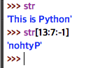

Ex:12

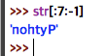

If I do not mention start number it will start from last only as we mentioned -1 as step size

Ex:13

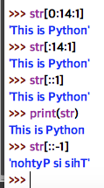

How can I get siht

Ex:14

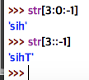

3. Repetition -> This can be done through star * operator

Ex:15

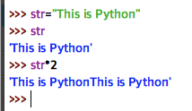

Ex:16

If I want only ‘This’ 3 times

Ex:17

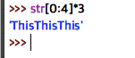

Removing Spaces from a String:

We have method lstrip and tstrip strip to remove spaces from a string

Lstrip cut spaces at left side

Rstrip cut spaces at right side

Strip cut spaces at both sides

Let’s say we have “ vijay kumar “

Ex:18

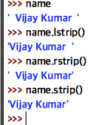

Finding s sub string: It will give substring start index. we use find() method here

Ex:19

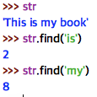

Counting substring: It will give total number of times substring present in actual string. we use count()method here

Ex:20

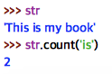

Replacing a substring: Here we replace substring with a new sub string. we use replace()

syn: replace(‘old sub string’,’new sub string)

Ex:21

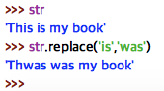

Changing case of a string: We can convert a string into complete either upper case or lower case, to implement this we have upper() and lower() methods.

Ex:22

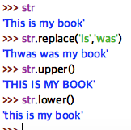

Making a string as Title: To make a string as title we use title()

method

Ex:23

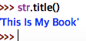

It makes all sub strings start letter into upper case.

**Comments in Python:**

We have only single line comment in python

# this is a single line comment

Multiline comments are not available in Python

But we can use triple single quotes or triple double quotes “”” “”” ‘’’ ‘’’ these for multiline comments

**Character:**

A String contains group of characters. There is no char data type in Python. We represent characters through strings only.

**Following are Collection Types**

1) List:

2) Tuple

3) Set and

4) Dictionary

A list is like array but here we store heterogeneous/different elements.

List is called versatile data type

Creating a list:

Ex:29

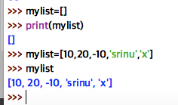

Retrieve elements of List:

We use for loop to retrieve elements of a list

Ex:30

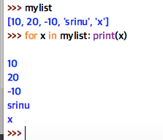

List supports Indexing, Slicing, Repetition and we can also modify the list elements

Indexing Ex:

Ex 31:

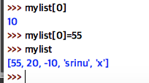

Slicing Ex:

Ex:32

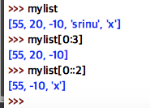

Ex:33

Reversing order of elements of list

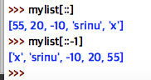

List supports multiplication using *

Ex:34

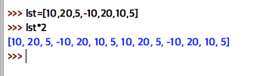

To find the number of elements in list we have len().

Ex:35

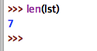

Ex:36

We can delete the list element using del()

Syn: del(list)

Ex:37

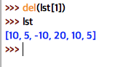

To delete a element another way is directly give element value to remove()

Syn: list.remove(-10)

Ex:38

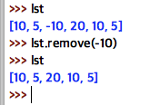

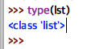

Clearing the list elements can perform through clear() method

Ex:39

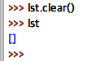

A function written inside a class is called a ‘method’

Calling function: fun()

Calling Object: obj.method() or class.method()

In the above examples: del() and len() are functions

remove() is the method from List class. Clear() is the method from List class

Slicing we can use for modification of elements also

Ex:40

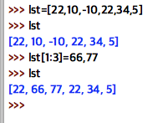

To find min and max value elements:

To find out minimum and maximum value elements

We have min() and max()

Ex:41

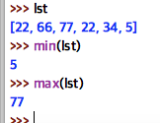

Index method always gives first occurrence of element.

Count gives total num of occurrence

To insert a new element into list we use insert()

Ex:42

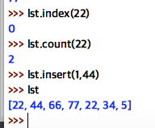

Coping list: We can do this using copy()

Ex:43

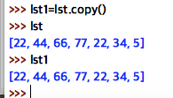

Sorting List: We can sort in both ascending and descending order using sort()

Ex: 44

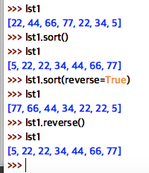

Tuple Datatype: Tuple is same as list. But we cannot modify it.

To create a tuple we use parenthesis ()

Creating a Tuple and Display their elements

Ex:45

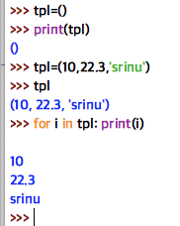

Ex:46

To write only 1 element in tuple we should use comma after element.

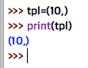

Indexing and Slicing can be done for tuples

Indexing:

Ex: 47

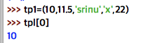

Slicing:

Ex:48

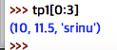

We cannot modify a tuple element

Ex: 49

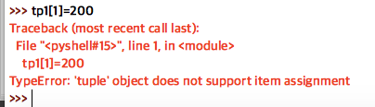

len(), max(), min() all 3 functions will work in tuples

Ex: 50

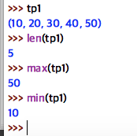

append(), remove(), insert() methods will not work on tuples.

Ex:52

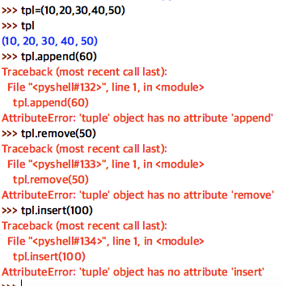

Sorting a Tuple: Sorting of a tuple can be performed using sorted function

Ex:53

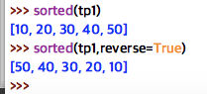

**Range**: Range data type represents collection of numbers. We cannot modify range numbers, range is used for repeating a for loop for a specific number of times.

Ex:54

range(5,10)

o/p: 5,6,7,8,9

10 is excluded

Ex:55

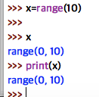

to retrieve range values, we use for loop

Ex: 56

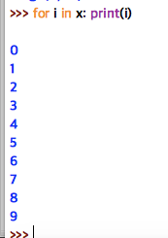

We can directly pass range in for loop without a variable

Ex:57

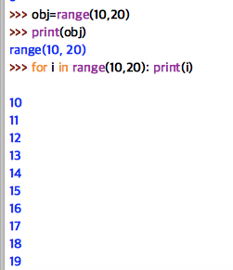

If I want to display elements side by side use end =’,’

To print range elements 100 to 200 alternative

Ex:58

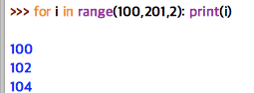

Set Datatype: A Set represents group of elements. A set stores elements in an unordered manner A set does not allow duplicate elements A set uses {}

Dictionary also uses {}

Why and When we use sets in real time:

When we ensure no duplication of elements into a list we go for sets

Creating a set:

Ex:59

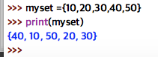

Set does not support indexing, slicing and repetition

Ex: 60

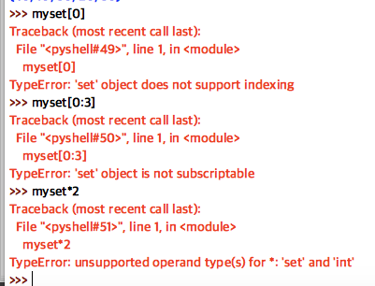

Update of set is possible:

Ex:61

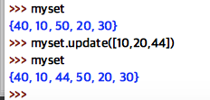

See 10 and 20 stored only once. set cannot store duplicates

set can also store diff type of elements like list.

Ex: 62

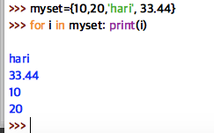

Ex:63

We can remove a element in set by using remove()

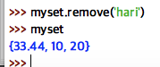

Ex:64

We can clear the set by clear()

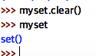

Frozenset -> It is also a set type. The main difference is set can be modified whereas frozen set cannot be modifiable.

We convert a set to frozenset by using frozenset()

Ex: 65

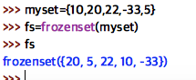

Frozen set cannot be modified

Ex: 66

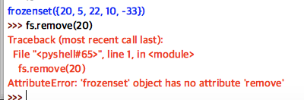

We can convert frozenset to set by using set() pass frozenset as parameter

Ex: 67

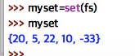

Dictionary Datatype:

It stores the element in the form of key, value pairs. dict type is used to represent a map.

dict represents dictionary that contains pair of element

We use {} to create a dictionary

Ex: a dictionary looks like {k:v,k:v,k:v}

Creating a dictionary

Ex: 68

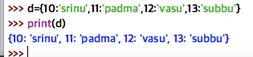

To retrieve keys we have keys()

Ex: 69

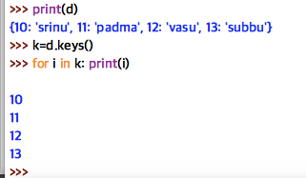

To Retrieve all values we have values()

Ex: 70

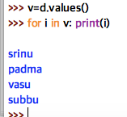

To Retrieve all key value pairs:

We have item() to retrieve all key values from the dict

Ex: 71

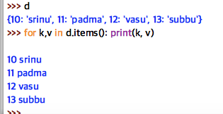

Use of dictionaries for example if we give key it should give us value. This is how we make use of dictionary

Ex: 72

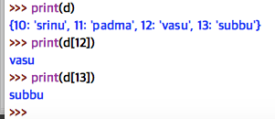

Length of dictionary can be found by using len() it gives no. of pairs

Ex: 73

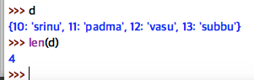

To delete a pair we use del() we should pass key as parameter

Ex: 74

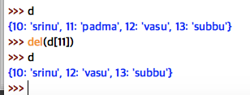

We can add key value to the dict list below

Ex: 75

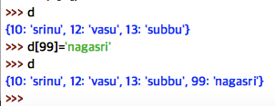

To see the memory address of dictionary use id(d)

Ex: 76

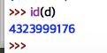

Here this big integer is the memory address of dictionary d.

**Python Literals:**

A literal is a constant value that is stored into a variable in a program.

There are 3 types of literals in Python

1. Numeric Literals: These literals represent numbers

Ex: a=10, b=100

1. Boolean Literals: These literals are True and False
2. String Literals: A group of characters is called string literal.

In python, there is no difference for single quotes and double quotes

To represents single or double quotes in a string we use “”” “”” triple quotes

**Escape Sequences in Python:**

\ = New Line Continuation

\\ = Display a single \

\’ = Display a single quote

\’’ = To display a double quote

\b = backspace

\r = Enter Button

\t = Horizontal table space

\v = Vertical table space

\n = New line

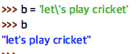

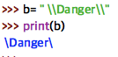

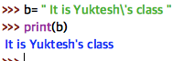

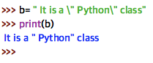

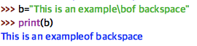

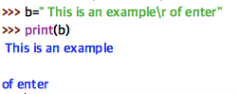

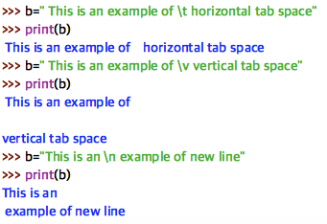

**Constants in Python:** Constant is like a variable but its value cannot be modified or changed in the program.

Like in Mathematics pi =22/7 it is all time constant

In c and Java languages once after we declare constants we cannot change their value in the program.

But In python, that is not possible a programmer can indicate a variable as constant by writing its name in capital letter. but it is changeable in python

Ex: MAX_VALUE

**Identifier in Python:**

An identifier is a name that is given to a variable or function or class etc.

Ex: Salary = 35,000

Here salary is identifier

Some example Identifier are salary, name, gross_income etc

**Key Words or Reserved Words in Python:**

These are the words python uses for purpose we cannot make these words for some other purpose. Following are the reserved words in Python

and del from nonlocal try

as elif global not while

assert else if or with

break except import pass yield

class exec in print false

continue finally is raise True

def for lambda return

**Operators in Python**

- Operator is symbol that performs some operation.

- An operator acts on some variables called operands.

- There are total 3 type of operators are available in python

They are

1. Unary operator
2. Binary operator
3. Ternary operator

We can classify operator in following types based on their nature.

1. Arithmetic operator
2. Assignment operator
3. Unary minus operator
4. Relational operator
5. Logical operator
6. Boolean operator
7. Bitwise operator
8. Membership operator
9. Identity operator

**1)Arithmetic operator:**

These operators are used to perform arithmetic operations.

|  |  |  |
| --- | --- | --- |
| Operator | Meaning | Example |
| + | Adds 2 values | a+b |
| - | subtracts 1variable from another | a-b |
| * | multiplies 2 variable values | a*b |
| / | divides left operand by right operator | a/b |
| % | Modules operator, Gives div reminder | a%b |
| ** | Exponent op, calculate exponent values | a**b |
| // | This is called floor division | a//b |

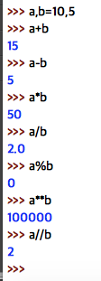

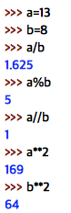

We should know how operations get perform in each expression:

1. First parenthesis are evaluated

2. Exponentiation is done next.

3. Multiplication, division, modulus and floor divisions are at equal priority

4.Finally, assignment operation is performed.

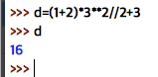

In the above expression if we trace

1. (1+2) =3
2. 3**2=9
3. 3*9=27
4. 27//2=13
5. 13+3=16

**Assignment Operators:**

These operators are used to store right side value to left side variable. Below are the assignment operators

If x=20, y=10, z=5

|  |  |  |  |
| --- | --- | --- | --- |
| Operator | Example | Meaning | Result |
| = | z=x+y | Stores x+y in Z | 30 |
| += | z+=x | z=z+x | 25 |
| -= | z-=x | z=z-x | -15 |
| *= | z*=x | z=z*x | 100 |
| /= | z/=x | z=z/x | Z=0.25 |
| %= | z%=x | z=z%x | Z=5 |
| **= | z**=y | z=z**y | 9765625 |
| //= | z//=y | z=z//y | Z=0 |

Ex1: Program to check all assignment operators

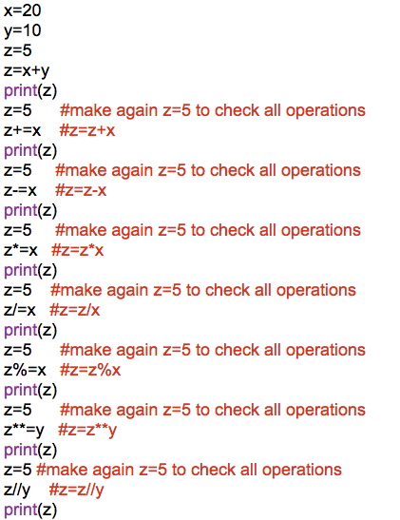

Op:

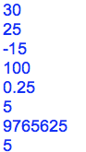

Note: In python, we do not have increment operator (++) or decrement operator (--) these are available in c and java.

You can assign variables in more flexible way like below.

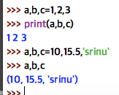

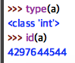

memory address is in binary format but id func will convert that into integer and gives to us

**Unary Minus Operator:**

This operator is denoted using -. If we place – before any variable its value is negated.

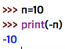

**Relational Operator:**

These operators are used to compare two quantities. We can understand out of two quantities which is small, big or equal. It results either true or false.

If a=1 b=2

|  |  |  |  |
| --- | --- | --- | --- |
| Operator | Example | Meaning | Result |
| > | a>b | Greater than | False |
| >= | a>=b | Greater than or equal to | False |
| < | a<b | Less than operator | True |
| <= | a<=b | Less than or equal to | True |
| == | a==b | Equals operator | False |
| != | a! =b | Not equals Operator | True |

Relational operators are generally used to construct conditions.

Ex1:

a, b=1,2

if (a>b):

print(“yes”)

else:

print(“No”)

Ex2:

x=15

10<x<20 #displays True

Ex3:

1<2<3<4 #will display True

1<2>3<4 #will display False

4>2>=2>1 #will display True

**Logical Operators:**

Logical operators are used to construct compound conditions. A compound condition is a combination of 1 or more simple conditions

Collection of all simple conditions result leads to compound condition result.

Note: In case of logical operators false indicates 0 and true indicates any number.

Ex: x =10 and y=4

Let’s write a program to understand logical operator.

Ex1:

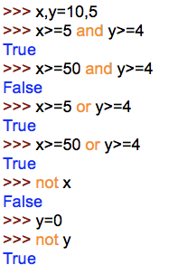

**Boolean Operators:**

- As we know there are 2 bool type variables ‘True’ and ‘False’ Boolean operators act upon bool type literals and provide bool type output.

- It means result provided by Boolean operator is also again True or False.

x=True and y=False

|  |  |  |  |
| --- | --- | --- | --- |
| Operator | Example | Meaning | Result |
| and | x and y | True and False = False | False |
| or | x or y | True or False = True | True |
| Not | not x | If x is True, it returns False, else True | False |

Let’sunderstandBoolean operators:

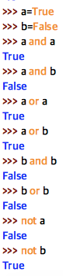

**Bitwise operators:**

Bitwise operators convert the data in the form of binary format, perform the operations on the binary data and gives the results in the form of decimal format.

There are 6 different types of bitwise operators:

1. Bitwise complement Op
2. Bitwise AND Op
3. Bitwise Or Op
4. Bitwise Xor Op
5. Bitwise Left shift Op
6. Bitwise Right shift Op

Let us do all operations on x and y

x=10 and y=4

10 if we convert into binary 1010. But it is not original format of binary representation. Actual format will be with 8 digits or 16 digits. Therefore, we need to add 4 digits i.e., 0000 at prefix

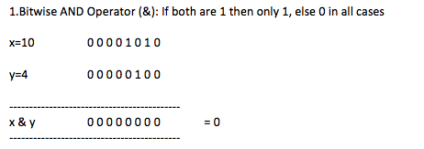

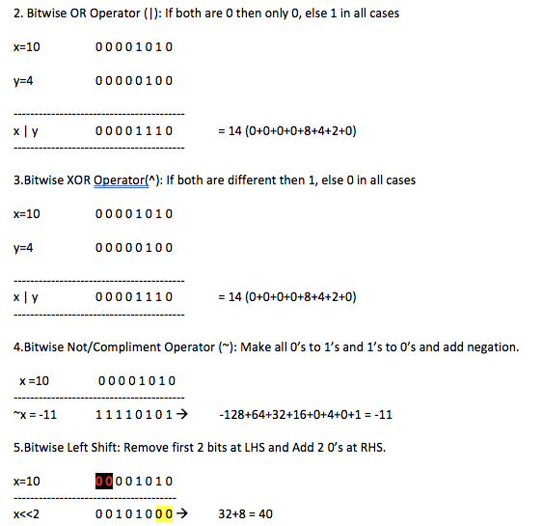

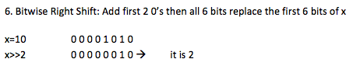

Programmatically let us implement all bitwise operators:

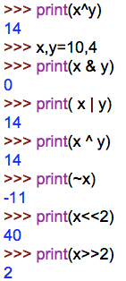

**Membership operators:**

These operators are useful to test for membership in a collection such as strings, lists, tuples or dictionaries

-There are 2 types of operators are there

1. in

2. not in

in operator:

It returns true if an element is found in the specified collection. else it returns false

not in operator:

It returns true if an element is not found in the specified collection. else it returns false

Ex: To check membership operators

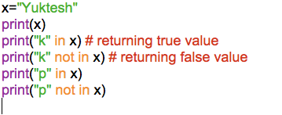

**Identity Operator:**

These operators compare the memory locations of two objects.

There are two identity operators.

1. is
2. is not

**The is operator:**

It is useful to compare the two objects are same or not. It will internally compare the identity numbers of the objects. If the identity numbers of the objects are same it returns true else false.

**The is not operator:**

It returns true if the identity numbers of two objects being compared are not same. If they are same returns false.

Let us write a program to understand identity operator

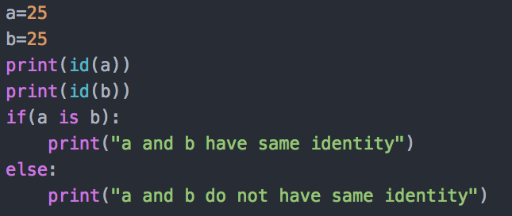

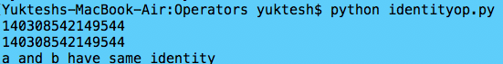

Let us write another program on lists now.

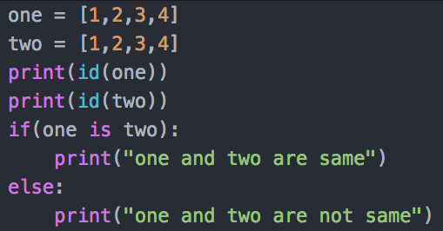

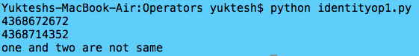

Though one and two list values are same by their memory locations are different that is the reason it displays not same as result.

To compare list elements, we should use == equality operator

if (one == two):

print(“one and two list elements are same.”)

else:

print(“one and two list elements are not same.”)

**Mathematical Functions:**

We can import math module and use these functions in our programs. Let us see few functions which are available in math module.

|  |  |
| --- | --- |
| Functions | Description |
| ceil(x) | Raises x value to the next highest integer |
| floor(x) | Decreases x value to the previous integer |
| degree(x) | Converts angle value x from radians to degrees |
| radians(x) | Converts x val from degree to radians |
| sin(x) | Gives sine value of x |
| cos(x) | Gives cosine value of x |
| tan(x) | Gives tangent value of x |
| exp(x) | Return exponentiation of x |
| fabs(x) | Gives the absolute value (or positive quantity) of x |
| factorial(x) | Gives the absolute value |
| sqrt(x) | Returns positive square root value of x |
| pow(x,y) | Raises x val to the power of y Ex: pow(5,3)=125 |
| trunc(x) | Real value of x is truncated to integer value. |
| Isnan(x) | Returns true if x is a NaN( Not a number) |

**INPUT and OUTPUT**

-To provide input to computer python provides some statements which are called Input statements.

-To provide output from computer python provides some statements called Output statements.

-Let us first understand how to display outputs in computer using different python output statements.

Output Statements:

-Python uses print() function for output statements. This function can be used in different formats.

(a)The print() statement:

When a print() function is called simply. It will throw the cursor to the next line

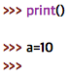

(b)The print(“string”) Statement:

When you pass the string to print function it will display as it is

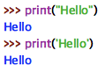

-Please observe in python there is no difference between “double quotes” and ‘single quotes’ both yields same results.

(c)We can use escape sequence in python.

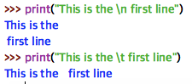

-To escape the effect of escape sequence, We should add 1 more \ back slash before the escape sequence character.

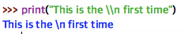

-We can use repetition operator to repeat the strings.

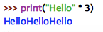

(d)The operator ‘+’ when is used on numbers will perform addition operation. same is not possible with strings but it can join 1 string with another string. Hence’+’ is called concatenation operator when used on strings.

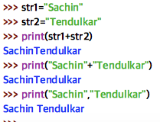

(e):print(Variable list) Statements:

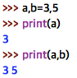

-We can separate variable values using separate variable called sep

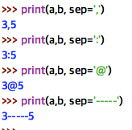

(f):To display print() outputs in 1 line we use end variable

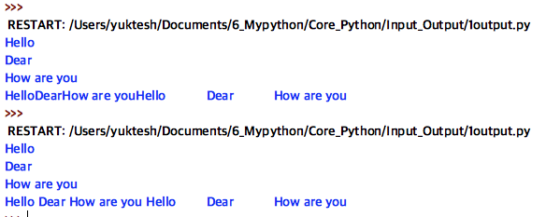

(g):The print(object) Statement:

We can pass objects like list, tuples or dictionaries to print() to display the elements of objects.

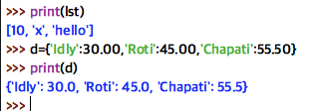

The print(“String”, variable list)

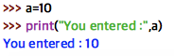

(h): Formatting strings in print():

The output displayed by the print() function can be formatted as we like. The special operator % can be used for this purpose. It joins a string with a variable or value in the following format.

print(“formatted string” % (variable list))

Here in formatted string we can represent

%i or %d to represent decimal numbers

%f to represents float values

%s to represent string values

Ex:1 Printing integer values

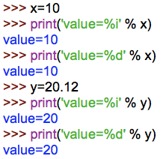

‘y’ given float value but still displaying integer as we gave %i

Ex2: Printing float values

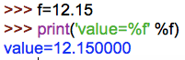

Ex3: Printing formatted string variables

-To display a string, we can use %s in the formatted string. When we use %20s, it will allot 20 spaces and the string is displayed right aligned in those spaces. To align towards left side in the spaces, we can use %-20s

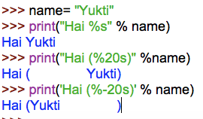

Ex:4 Print char values

-We can use %c to print single characters

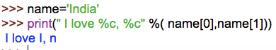

-We can use slicing operator to display required characters from the string.

name[0:2] # it gives 0th and 1st element

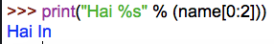

-To display float values in more broader way we can use %f as

%8.2f

Ex:5 Altering float values

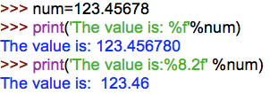

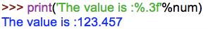

(I)Replacement field in print()

In place holder, we can display variable values

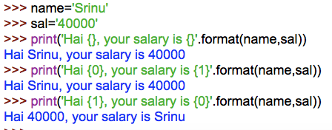

**Input Statements:**

To accept input from keyboard. Python provides input() function. This function takes a value from the keyboard and returns it as a string.

P1: To accept a string from the keyboard

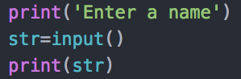

o/p:

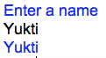

P2 with end:

To display user input in the same line means we should use ‘end’ attribute

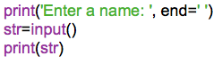

o/p:

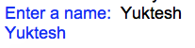

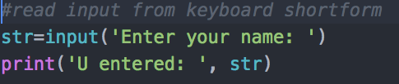

o/p:

P1 version v2:

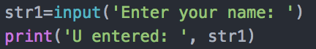

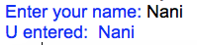

To accept an Integer from a keyboard:

P3:

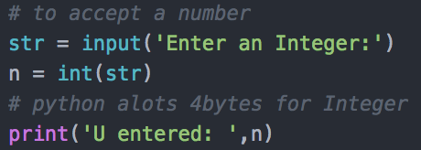

o/p:

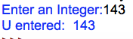

P3 V2:

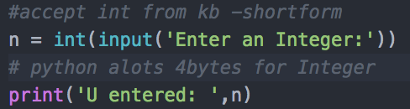

o/p:



P2 V3:



To accept float values from the keyboard:

P3:

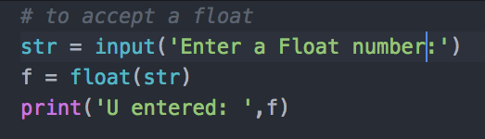

o/p:

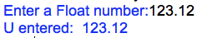

P3 V2

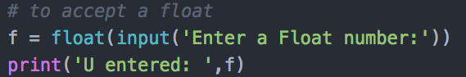

o/p:



P3 V3



o/p:



To accept char from the keyboard:

P4:

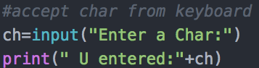

o/p:

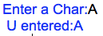

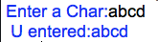

P5: To accept a single character from keyboard

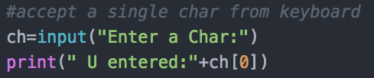

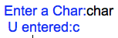

P5: Write a python program to accept 2 integers from keyboard

P6: Write a python program to accept 2 numbers and find their sum

P7: Write a python program to find sum and product of 2 numbers

-To accept more than 1 input from the same line, We can use for loop along with input() function.

a,b=[int(x) for x in input(“Enter two numbers:”).split()]

* input function will display msg as “Enter two numbers”
* The user entered numbers will take it as string and separate by split() method
* We got 2 strings as elements of list
* These strings are read by for loop and converted into integers using int function.
* These integers are finally stored in a,b
* split() method by default splits the values where a space is found.
* So, while entering numbers user should give a space between 2 numbers
* [] these braces indicate it is a list.

P6: Write a python program to accept 3 integers from keyboard and find their sum

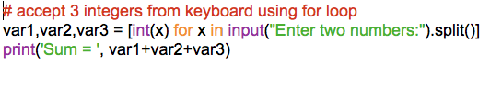

o/p:

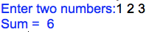

P7: Write a python program to accept 3 integers from keyboard separated by, and find their sum

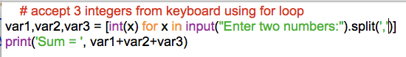

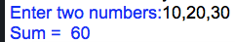

Find number of strings

lst = [x for x in input(‘Enter strings’).split(‘,’)]

print(lst)

n = len(lst)

print(“no of string”, n)

eval() and input():

We can use eval() along with input()

P8: Program using eval() and input()

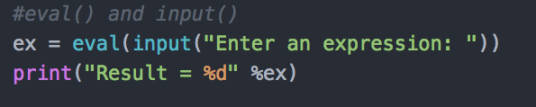

o/p:

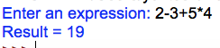

We can use eval() and accept list in input()

**Control Statements**

**Control Statements:**

These are the statements which control or change the flow of execution. Following are the control statements available in Python

* if statement
* if…else statement
* if…elif…else statement
* while loop
* for loop
* else suit
* break statement
* continue statement
* pass statement
* assert statement
* return statement

Note: Switch statement is not available in Python

**The if statement:**

This statement is used to execute 1 or more statements depending on whether a condition is true or not.

Syn: if condition:

statements:

- First condition is tested. If it is true then only statements will get execute. Condition

should write colon(:)

Program1:

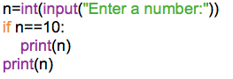

Program 2:

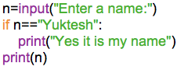

**The if … else statement:**

This executes a group of statements when condition is True, otherwise it executes another group of statements.

-Syn: if condition:

statements1

else:

statements2

Program3:

Write a python program to test a number is even or odd

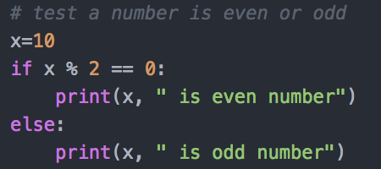

o/p:



Program4:

Write a python program to accept a number from keyboard and test whether it is even or odd

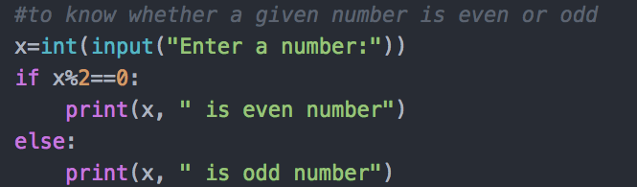

o/p:

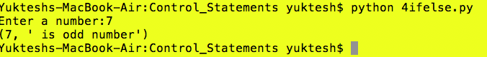

Program5:

Write a Python program to test whether a given number is in between 1 to 10

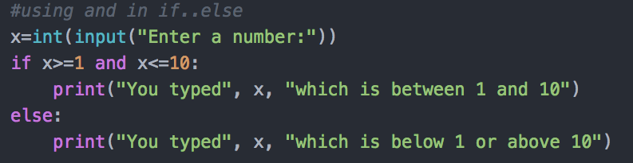

o/p:

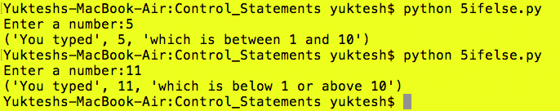

**The if..elif..else statement:**

Sometimes, the programmer should test multiple conditions and execute statements depending on those conditions. In those situations, we use if..elif..else statement.

Syn: if condition1:

stmts

elif condition2:

stmts

elif condition3:

stmts

else:

stmts

Program6:

Write a python program to know whether a given number is 0 or +ve or –ve

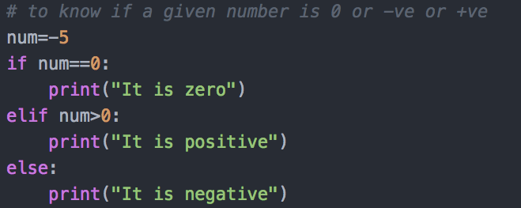

o/p:



Program7:

Write a python program to accept a digit from keyboard and display in words

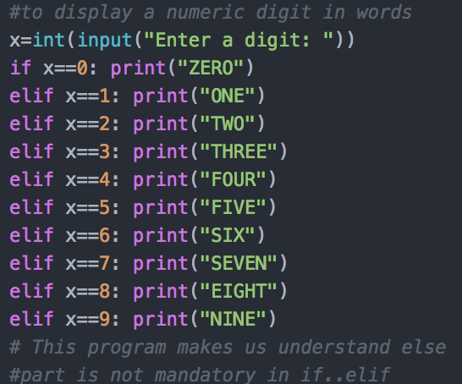

o/p:

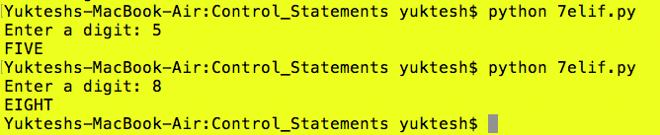

**Looping Statements:**

Looping statements are used to execute set of statements repeatedly.

Python supports 2 types of looping statements

(1) While

(2) For

**The while:**

- While loop executes set of statements repeatedly until condition become false

-Syn: while condition:

statement1

statement2

--------------

Program 8:

Write a python program to display numbers from 1 to 10 using while loop.

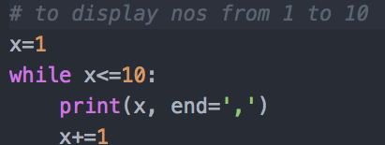

o/p:



Program 9:

Write a python program to display numbers from m to n.

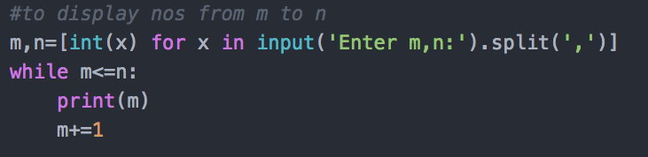

o/p:

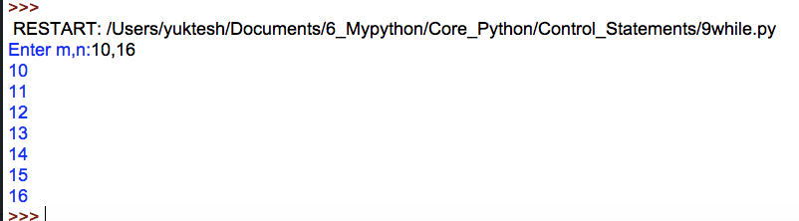

Program 10:

Write a Python program to display even numbers from m to n

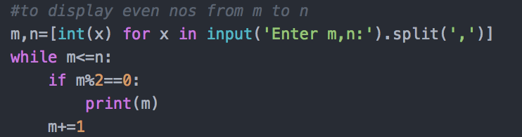

o/p:

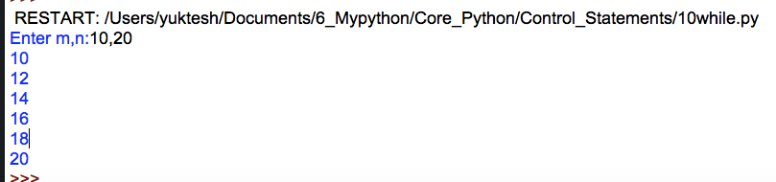

**for loop:**

- for loop executes set of statements with respective to every element of given iterable object.

- We work with collections using for loop.

-The for loop is useful to iterate over the elements of a collection. It means for loop executes based on number of elements in collections.

- First elements of a collection are assigned to variable written after ‘for’ and then statements are executed

- Next, second element in this way for each element of the collection the statements are executed.

-So, for loop is executed as many times as there are number of elements in the collection.

Syntax: for var in iterableobj:

---

---

---

Program 11:

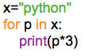

Op:

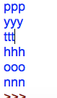

**range():** It is a predefined function which stores the number of values specified in parameters.

Ex: range(10): Here it will stores values from 0 to 9, here 10 is exclusive

Program 12:

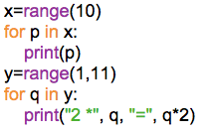

Op:

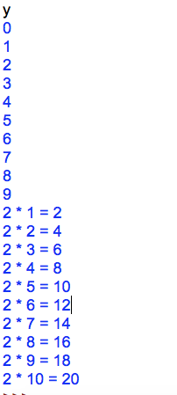

Program 13:

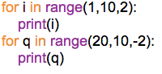

Op:

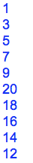

Program14:

Write a Python program to display characters of a string using for loop

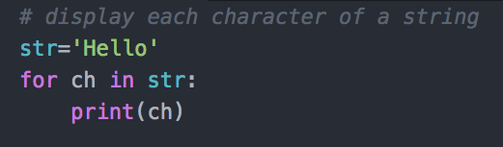

o/p:

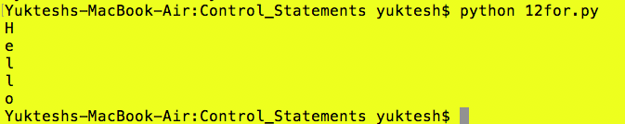

Program15:

Write a Python program to display each character of a string using index

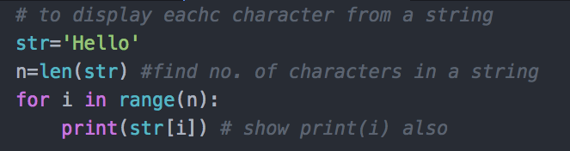

o/p:

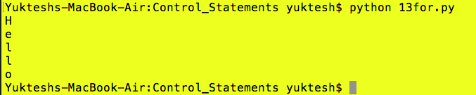

Program16:

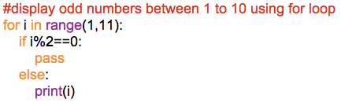

Op:



Program 17:

Writing above program in another way

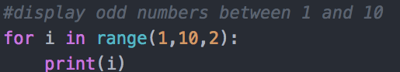

o/p:

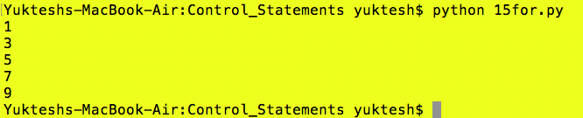

Program 18:

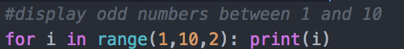

o/p:

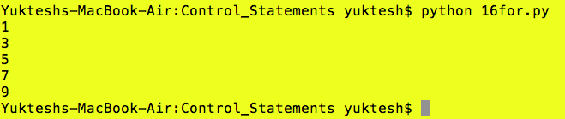

Program 19:

Write a Python program to display numbers from 10 to 1 in descending order



o/p:

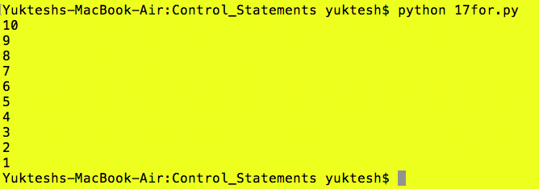

- In above program, we used range(10, 0, -1)

- Here starting number is 10 and ending number is 1 before 0 (that’s why we kept 0) and step size is -1 it means we should decrement 1 every time. Thus, we get 10,9,…1.

- Observe that it will not return 0 as the last number. It will stop at 1 that is one number before 0.

Program 20:

Write a python program to display elements of a list using loop

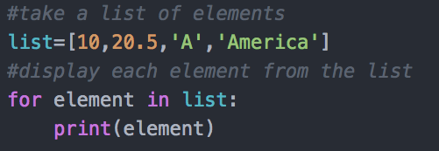

o/p:

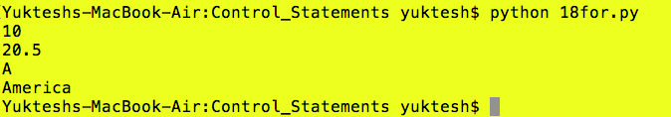

Program 21:

Write a python program to find the sum of list of numbers using for loop

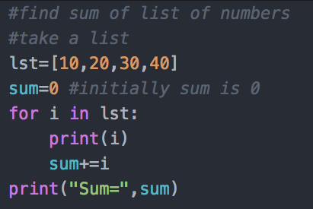

o/p:

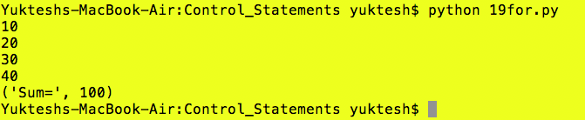

Program 22:

Write a Python program to understand infinite loop

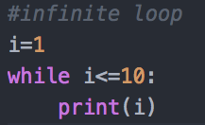

o/p:

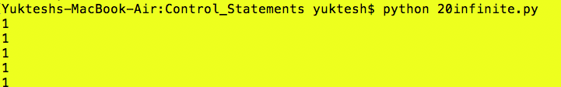 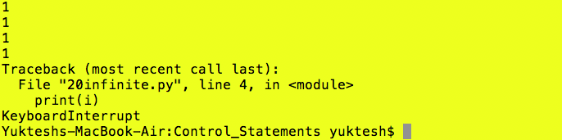

**The else suit:**

- It is possible to use else statement along with for loop and while loop

- Syn: for var in sequence:

stmts

else:

stmts

-Syn: while cond:

stmts

else:

Program 23: Using while - else

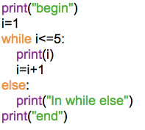

Op:

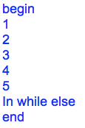

Program 24: Using while - else

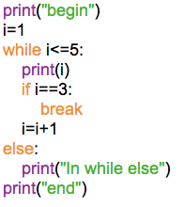

O/p:

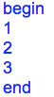

Program 25: Using for – else

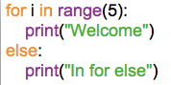

O/p:

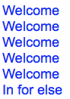

Program 26:

Write a python program to search an element in the list of elements

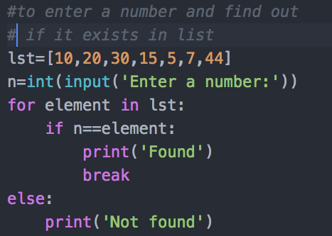

**break:** break is a statement, which can be used in looping statements. whenever control reach to the break statement of a loop then loop execution will be terminated.

Generally, we use break statement to exit from the infinite loops.

Program 27:

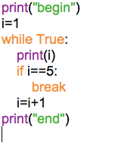

Op:

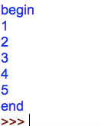

Program 28:

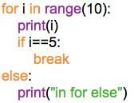

Op:



**continue:**

It is a statement, which can be used in looping statements.

Whenever control reached to the continue statement of a loop then without executing remaining statements of that iteration control will go to the next iteration.

Program 29:

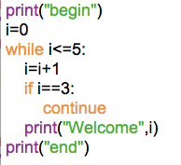

o/p:

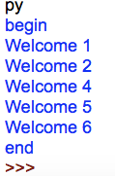

**pass:**

The pass statement does not do anything. It is used with if statement and loop statements to represent no operation.

-When we use pass statement we need statement syntactically but we do not want any operation.

Program 29:

Write a Python program to understand pass statement

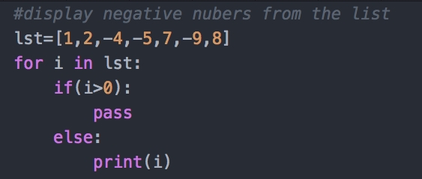

o/p:

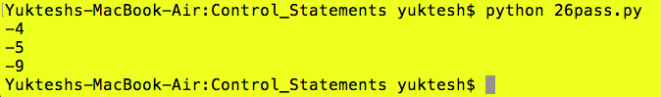

**The assert statement:**

The assert statement is useful to check if a condition is fulfilled or not.

Syn: assert condition, message

Ex: assert x==0, “wrong input entered”

PVM checks condition if it is True next statements will execute else it will display the AssertionError along with the message “wrong input entered”

Program 30:

Write a python program to assert that user enters a user enters a number greater than 0

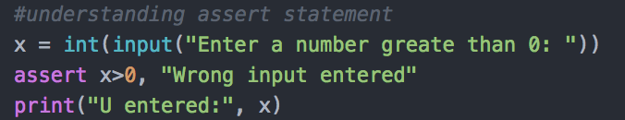

o/p:

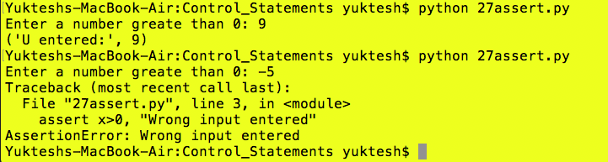

**The return statement:**

-The return statement is useful in functions

-functions will process some logic and return the result to the program

-this can be performed by function using ‘return’ statement

Program 31:

Write a program to write a function and return the result of function using return statement.

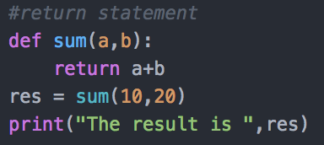

o/p:



Program 32:

Write a python program to use return statement.

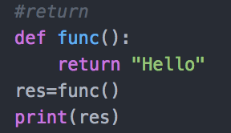

o/p:



Program 33:

Write a python program to test a given number is prime or not.

Program 34:

Write a program to generate odd numbers from m to n using while loop

Program 35:

Write a Python program to display prime number series up to given number.

Program 36:

Write a Python program to generate Fibonacci series.

**Collections**

**Collections:**

- Collection types represented classes objects are store in other objects and we call those objects as ***elements.***

- Every collection type represented class provides some methods and by using those methods we can perform the operations on the elements of the collection.

- All collection types represented classes objects are iterable.

- Important python collection types are.

1. list
2. tuple
3. set
4. dict

**1.List:**

- List objects can be created by using square brackets or by calling list() function.

- List objects are mutable objects

- Insertion order is preserved in list.

- List supports both positive and negative indexing

- Heterogeneous elements and duplicate elements are allowed in list.

Ex1: Write a python program to understand list

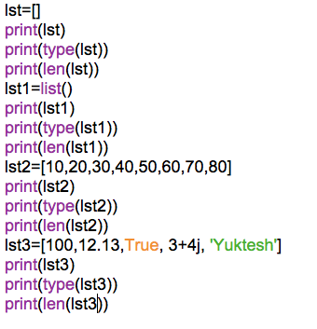

Op:

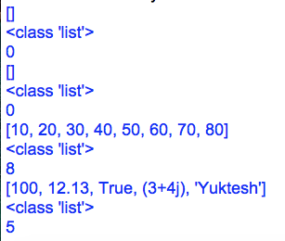

Ex2: Program to perform slicing and indexing on list.

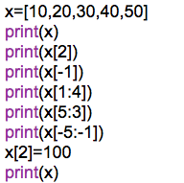

op:

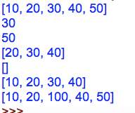

Ex3: Program to search for a required element is available or not available in list.

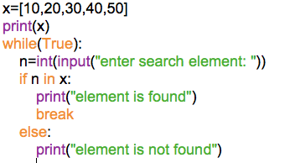

op:

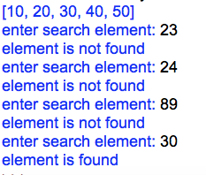

Ex4: Find sum of all elements in the list

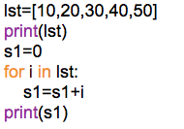

op:

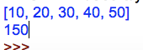

Ex5: Performing nested operation on list

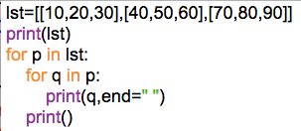

op:

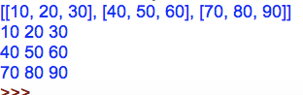

**Working with list methods:**

append() – Add single element to the list

extend() – Add elements of a list to another list

insert() – Insert elements to the list

remove() – removes elements from the list

index() – returns index value of an element of list

count() – returns occurrences of element in a list

pop() – Removes element of given index

reverse() – Reverses a list

sorts() – Elements of a list

copy() – Returns shallow copy of list

clear() – Removes all elements from the list

Ex6:

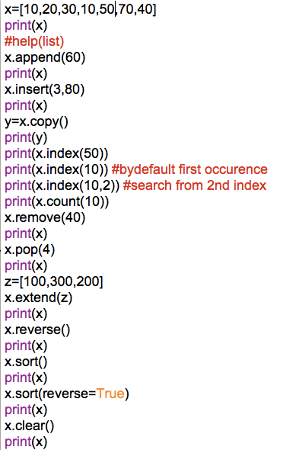

op:

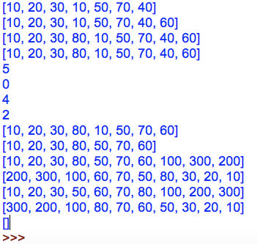

**List comprehensions:**

-The concept of creating new lists from an iterable object ( like a list, set, tuple, dictionary or range) that satisfy a given condition.

- List comprehension contains very compact code.

Ex7: To find squares from 1 to 10

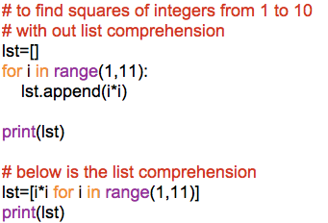

op:

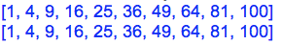

Ex8: Program to generate 1 to 10 even numbers

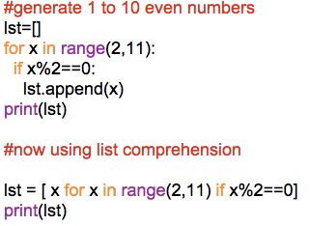

op:

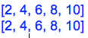

**2. Tuple:**

- Tuple objects can be created by using parenthesis or by calling tuple function or by calling multiple values to a single variable.

- Tuple objects are immutable

- Insertion order is preserved.

- Duplicate elements are allowed

- Heterogeneous elements are allowed

- Tuple supports both positive and negative indexing.

Ex9: Various ways of creating tuples

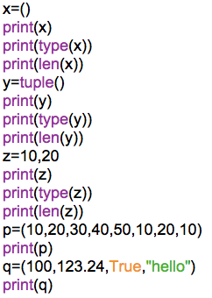

op:

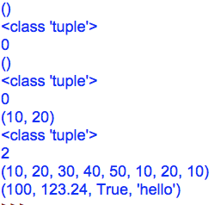

Ex10: Slicing on the Tuple

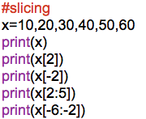

op:

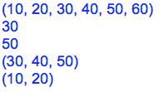

Ex11: Indexing on the Tuple

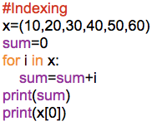

op:

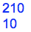

Ex12: Working with nested Tuples

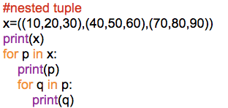

op:

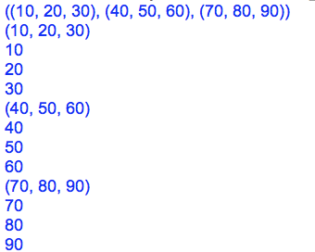

Ex13: Tuple is immutable

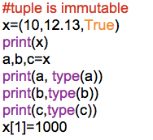

op:

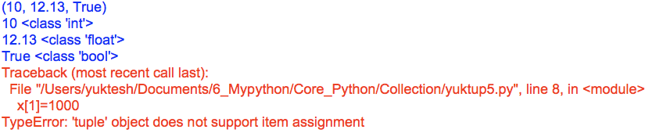

**Tuple Methods:**

Tuple is immutable. We cannot change elements of tuple once it is assigned.

Therefore, there are only 2 methods that tuple object can call

1. count() – returns the occurrence of elements of list
2. index() – returns index of an element

**Differences between List and Tuple:**

|  |  |
| --- | --- |
| **List** | **Tuple** |
| 1.List objects are mutable | 1. Tuple objects are immutable |
| 2. Applying iterations on list objects takes longer time | 2. Applying iterations on tuple objects takes less time |
| 3. If the frequent operation is insertion or deletion of the element then it is recommended to use list | 3. If the frequent operation is retrieval of the elements then it is recommended to go for tuple |
| 4. List can’t be used as ‘key’ for the dictionary | 4. Tuple can be used as a key for the dictionary if the tuple is storing only immutable elements. |

**3. Set:**

- set objects can be created by using curly braces {}

- Insertion order is not preserved in set

- Duplicate elements are not allowed

- Heterogeneous elements are allowed in set

- set is not supporting indexing

- set objects are mutable objects

- Elements of the set must be immutable

- We can perform the mathematical set operations like union and interaction.

Ex14: Various ways of creating a set.

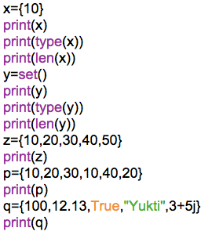

op:

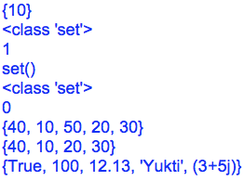

-Tuple can be stored in set as it is immutable object.

- If Tuple contain mutable element (like list) then it will not allow to store

- Set in set also not allowed, because set in set is mutable.

Ex15: Working on set elements.

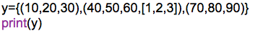

op:

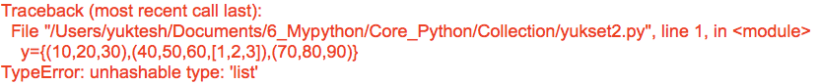

Ex16: Working with set methods

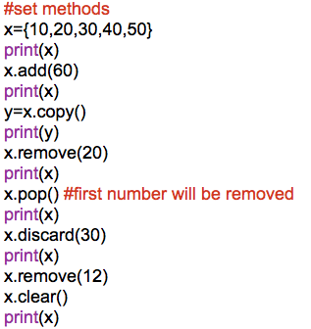

op:

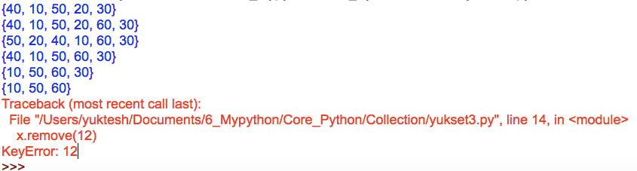

Ex17: Working with mathematical set operations.

Results will be sorted automatically

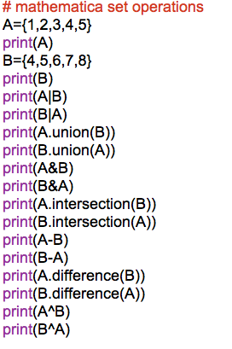

op:

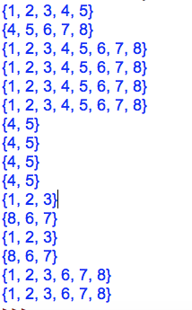

**Set comprehension:**

The concept is generating the elements into the set object by writing some logic in the set known as ‘set comprehension’

Ex18:

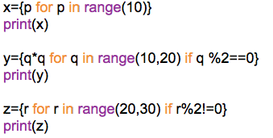

op:

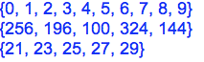

**4. Dict:**

- dictionary objects can be created by using curly braces {} or by calling dict() function

- dictionary objects are mutable objects

- dictionary represents key-value pair

- Each key-value pair of dictionary is known as an item

- Dictionary key must be immutable

- Dictionary values can be mutable or immutable

-Duplicate key cannot allowed but values allowed

- Insertion order is preserved

- Heterogeneous keys and heterogeneous values are allowed

Ex19: Various ways of creating dictionary

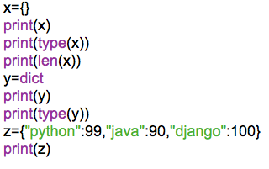

Op:

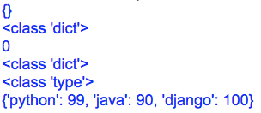

Ex20:

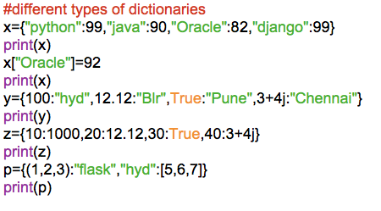

op:

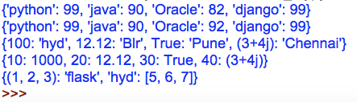

Important methods of dictionary:

1. dict() – Creates empty dictionary
2. len() – Returns the number of items in the dictionary
3. clear() – To remove all elements from the dictionary
4. get() – To get the value associated with key
5. pop() – It removes the entry associated with the specified key and return the corresponding value
6. popitem() – It removes last item(k-v) from the dictionary and returns it.
7. Keys() – It returns all keys associated with dictionary
8. values() – It returns all values associated with dictionary
9. Items() – It returns list of tuples representing key value pairs
10. Copy() – Creates exact duplicate dictionary.

Ex21:

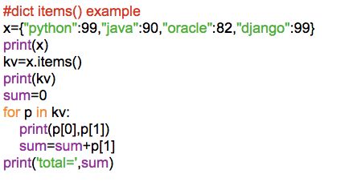

Op:

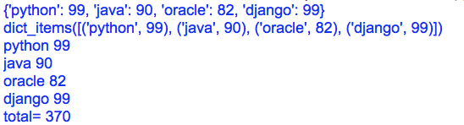

**Ex: 22**

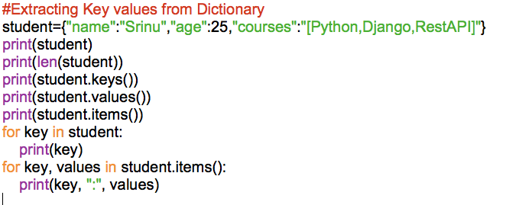

**Ex23: Working with dictionary**

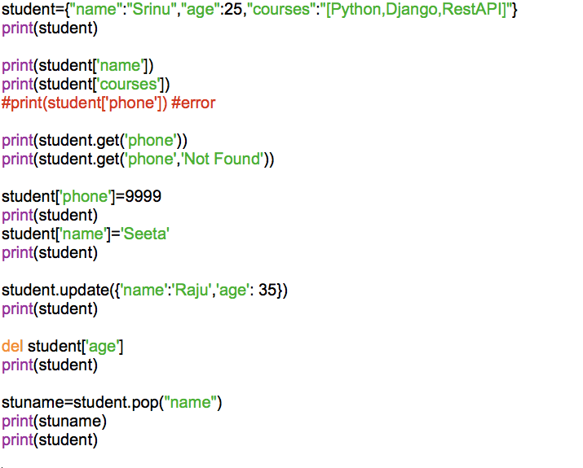

**Ex24: Reading dictionary from the keyboard**

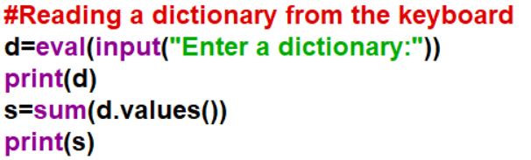

**Nested Dictionaries:**

Nested dictionary is possible only by keeping dictionary as values for different keys as we cannot keep key as dictionary as it is mutable.

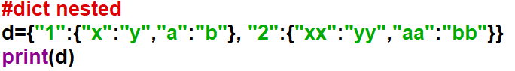**Dictionary Comprehension:**

The concept generating items into the dictionary by writing some logic in the dictionary is known as dictionary comprehension.

Ex25

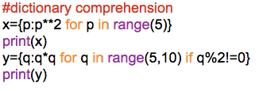

Op:

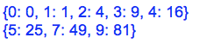

|  |  |  |  |  |
| --- | --- | --- | --- | --- |
|  | List | Tuple | Set | Dictionary |
| Hetero | Yes | Yes | Yes | Yes |
| Duplicates | Yes | Yes | No (It will take but will not display) | Keys – No(It will take but overrides)  Values - Yes |
| Insertion order | Preserved | Preserved | Not Preserved | Preserved |
| Data Type | Mutable | Immutable | Mutable | Mutable |
| Elements Type are | Mutable and Immutable | Mutable and Immutable | Immutable | Key must be immutable, Value can be anything |
| Indexing | Yes | Yes | No | NA |
| Modify elements | Yes | No | Yes | Yes |
| Slicing | Yes | Yes | No | NA |

**Function:**

- Group of statements to perform some task.

- A function can or cannot contain return type

- A function written inside in a class called Method

- Method can be called as obj.method() and class.method()

Syntax of defining a func:

Ex: def func-name()

**Program 1:** Write a python program with a function.

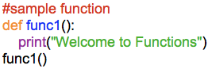

**Program 2:** Write a python program to find sum of a and b using functions.

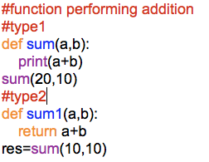

**Program 3:** Write a python program to find the addition of given numbers

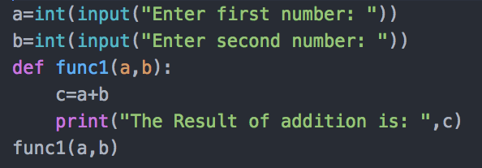

**Program 4:** Write a python program to test the given number is even or odd

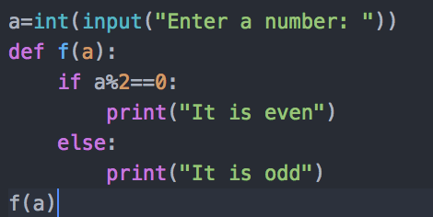

(B)A function can return more than 1 value. If more values to be returned, then we need to capture them in more variables

**Program 5:** Write a python program which a func should return 2 values.

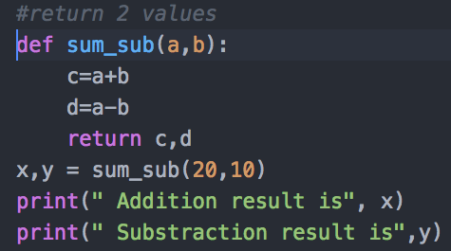

(C)In python function is treated an object. Therefore, we can use function in following ways

1. It is possible to assign a func to a variable

2. It is possible to define 1 func inside another func

3. IT is possible to pass 1 func as parameter to other func

4. It is possible to return 1 func as return to another func

**Program 6:** Write a python program in which assign a function to a variable

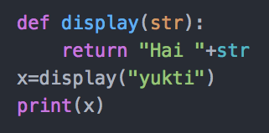

**Program 7:** Write a python program to define a func inside another func

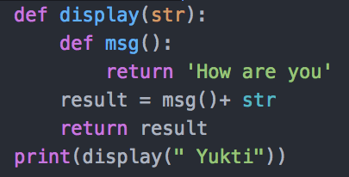

**Program 8:** Write a python program in which function should be a parameter to other function

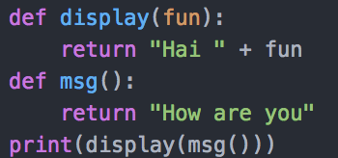

**Program 9:** Write a python program to know how a func can return another func

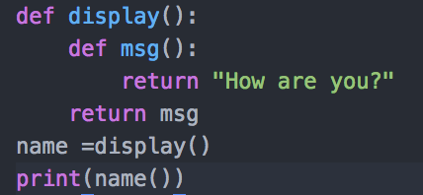

o/p:



(D) **Pass by value & pass by Reference**

In python, we do not have this concept. Here everything we treat it as like object

In python, the values are sent to functions by means of object reference

- When we pass an integer to a function, Reference of integer object is passed

**Program 10:** Write a program to pass an integer to a function and modify it

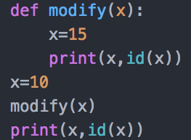

o/p:

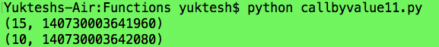

Note: Integer objects are immutable. (Not modifiable)

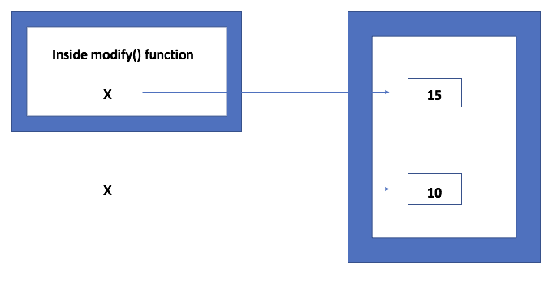

Passing Integer to a function

In python integers, strings, floats and tuples are immutable. If we try to change their data a new object gets created with modified value. whereas lists and dictionaries are mutable. That means when change their data the same object gets modified new object will not get create.

**Program 11:** Write a python program to pass a list to a function and modify it

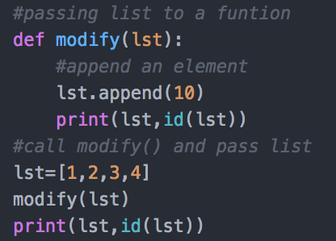

Op:

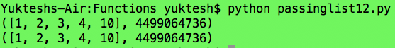

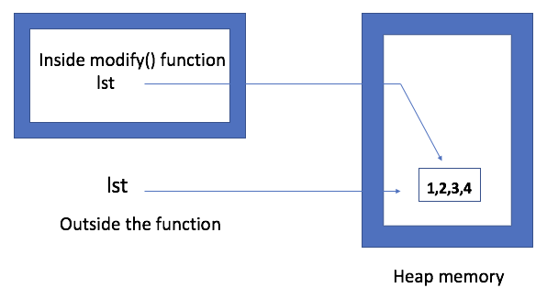

Passing a list to the function

**Arguments in Functions**

There are two types of parameters we can pass to function. They are

1. Formal Arguments
2. Actual Arguments

**Program 12:** Write a python program to understand formal and actual arguments.

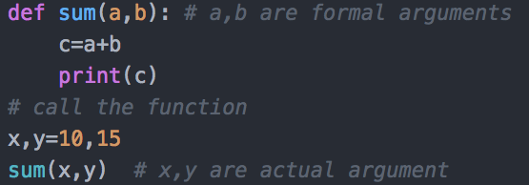

o/p:



-In the above program if you see when we define function we passed 2 arguments a, b these are called formal arguments

and when at the time of calling function we passed 2 arguments x, y these are actual arguments.

-At the time of function call we can pass actual arguments in 4 different types.

1. Positional arguments

2. Keyword arguments

3. Default arguments

4. Variable length arguments

Positional Arguments:

-These are arguments passed to function with proper order.

-If we do not pass in order then PVM will take as it. But if we pass more arguments than the formal arguments then PVM will raise an error.

**Program 13:** Write a python program to understand Positional Arguments.

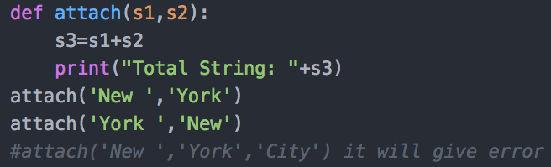

Keyword Arguments:

These arguments identify the parameters by their names. We not really required to follow the order in passing these arguments to a function.

**Program 14:** Write a python program to understand Keyword Arguments.

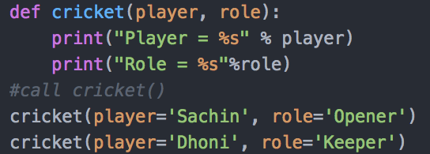

Default Arguments:

Here for the arguments we set a default value and when we call even if we do not pass any value it will take the default value

**Program 15:** Write a python program to understand default arguments

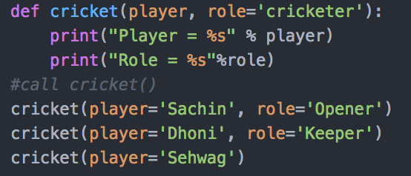

Variable Length Arguments:

This argument can take n number of values as input. This we specify using * symbol in format arguments

**Proram 16:** Write a python program to understand Variable length arguments

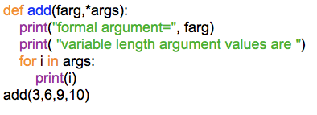

**(E) Local & Global Variables**

Local variable:

A variable which is written inside function, its scope is only with in the function. It is not available outside of function

Global variable:

A variable which is outside of function, its scope is in entire program it means it is available for entire program

**Program 17:** Write a python program to understand local variables

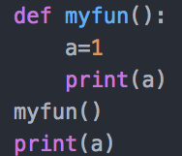

**Program 18:** Write a python program to understand global variable

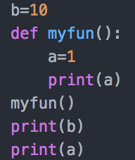

Global keyword:

It is used to access global variables inside functions

**Program 19:** Write a python program to understand global keyword.

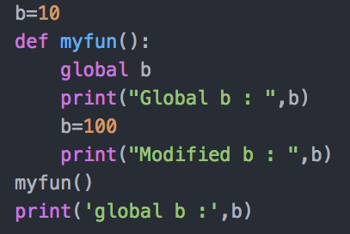

**(F) Recursive Functions:**

A function calling itself is known as Recursive function

**Program 20:** Write a program to understand recursive function

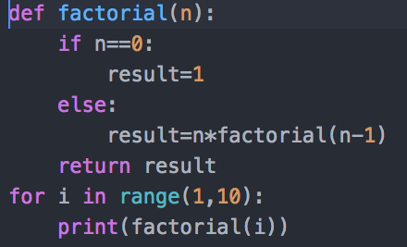

**(G) Anonymous Functions or Lambdas Function:**

- A function which doesnot contain any name is known as lambda function or anonymous Functions

- Instead of ‘def’ keyword we use ‘lambda’ keyword to represent lambdas

Syn: lambda arg_list: expression

- Lambda function we assign to the variable and we can call that function through that variable.

**Program 21:** Write a python program to create a lambda function that returns square.

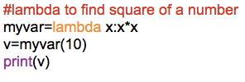

The above lambda function is equal to the following code.

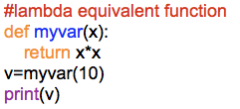

Whenever we want to pass 1 function as a parameter to the other function then it is recommended to use lambda function.

**Program 22:**

**Program 23:** Write a program to find a number is even or odd using lambdas

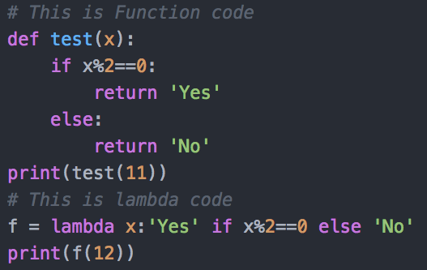

**Prorgam 24:** Write a python program to find sum of 2 numbers using lambdas

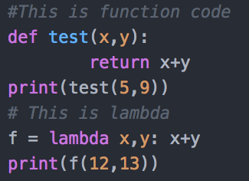

**Using Lambdas with filter() Function:**

- filter() function is useful to filter out the elements of a list

- Syn: filter(function, collection)

- We should supply a function and collection. Based on function it will filter the collection.

**Program 25:** Write a python program using filter() to filter out the even elements from the list.

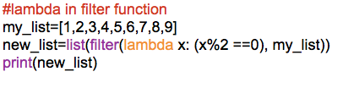

op:



**Using lambdas with map() Function:**

* map() function acts on every element and modifies every element in list

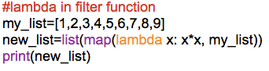

op:

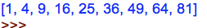

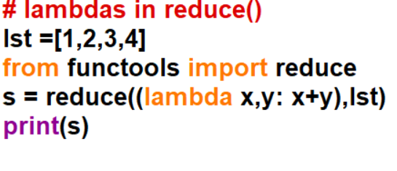

**Function Decorators:**

- Decorator is function that accepts a function as parameter and returns a function.

- A decorator takes result of a function, modifies the result and returns it.

- Decorators are useful to perform some additional operation to the function.

- Steps to create a decorator function

1. we should define decorator with another function as parameter

def décor(func):

1. We should build another function inside decor()
2. Now return the inner() as return value of decorator function.

- Now call decor() by passing a function(num) as parameter. Result is stored in a variable

- Print the variable to see the effect of decorator on the function(num)

**Program 26:** Write a python program to increase a function result by 2 using decorator

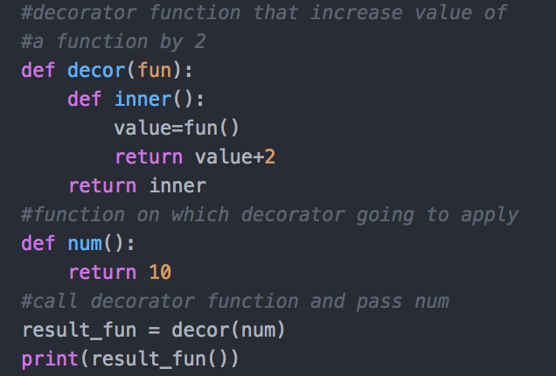

-To apply the decorator function to any other function we can use ‘@’ symbol.

**Program 27:** Write a python program to rewrite above program using @ symbol.

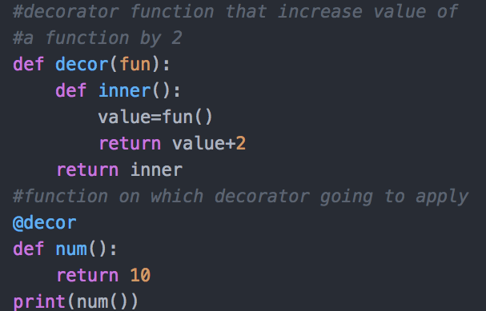

**Generators:**

-Generators are the functions which returns sequences of values.

-Here we use ***yield*** statement to return value from a generator function

**Program 28:** Write a python program using generator function.

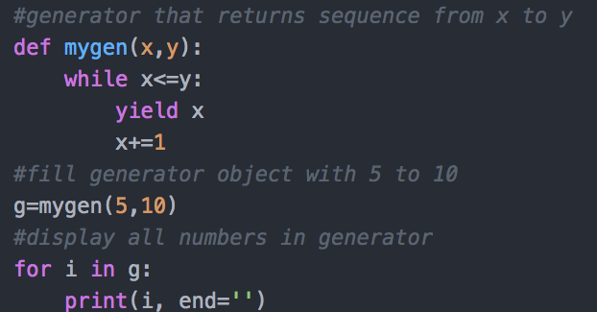

**Module:**

-Every python file itself is known as a module.

- A module can contain global variables, executable statement, functions and classes.

- The properties of one module we can use into another module by using import statement.

- Python supports two types of import statements

(i) Normal import (ii) From import

**Normal import:**

- In normal import entire python file or module is imported.

- Whenever we import a module by using normal import statement we can access the properties of that module by using that module name.

**Mod1.py**

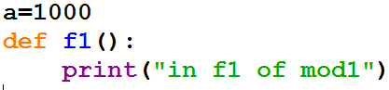

**Mod2.py**

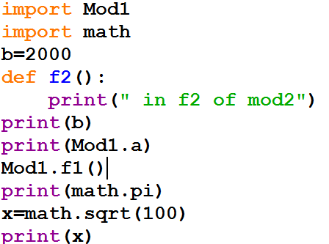

-At the time of importing a module by using “normal import” statement we can create the alias name for the module and we can access the properties of that module through alias name.

- After creating the alias name for a module we are not allowed to access the properties of that modules through its original name.

**Mod3.py**

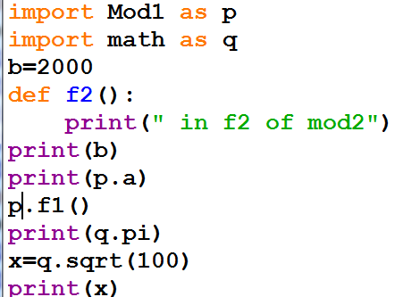

**From import:**

-By using from import we can import the required properties of a module.

-The properties which are imported by using from import we can access those properties directly without using module name or alias name.

**Mod4.py**

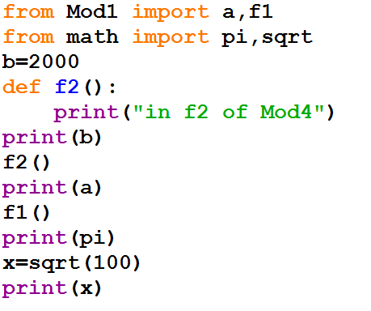

**Mod5.py**

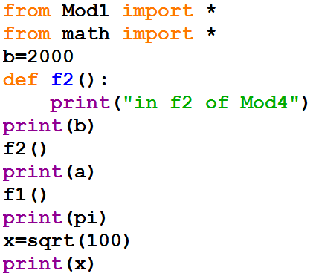

**builtins Module:**

- “*builtins”* is a predefined module which contains frequently used functions. Python interpreter imports “builtins” module for each and every python file automatically

-We can use the properties of “builtins” modules directly without import it explicitly.

- To know what all “buitins” module provides



Ex:

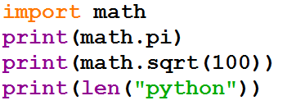

**Note:** It is not recommended to use the from import with * as performance of the application will be degraded

**Packages:**

- Package is nothing but a folder or directory which represents collection of modules.

- Packages can also contain sub packages

- We can import the modules of the package by using packagename.modulename

- We can import the modules of the sub packages by using packagename.subpackagename.modulename

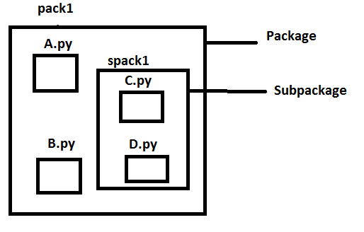

**Structure of package:**

**a.py**

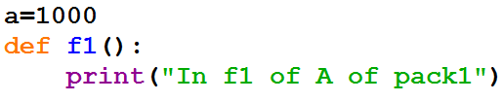

**b.py**

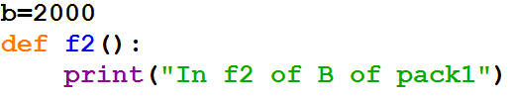

**c.py**

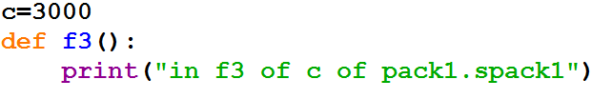

**d.py**

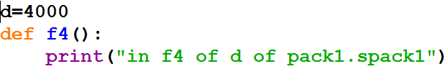

**Test.py**

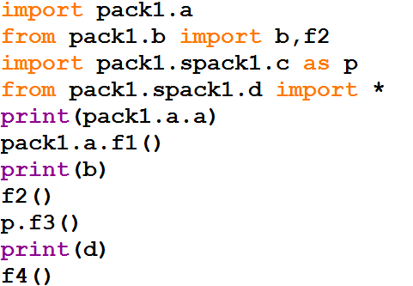

**Installing a Third party Module:**

-Steps to install a third-party module.

step1: First, check required module available in python software or not by using below command in idle.

>>>help(‘module’)

displays all available module

step2: If your module is not available then goto command prompt and type

pip install modulename

Ex: pip install numpy

-Here pip is an application in python interpreter which helps in installing other softwares(libraries) related to python.

Now, After installation repeat step1 you can see installed module.

-To uninstall a third party Module, just type “pip uninstall modulename” in cmd.

Ex: pip uninstall numpy

To work with arrays we use Numpy module:

NumPy - NumPy is a library for the Python programming language which is useful to deal with scientific calculations and also to process single and multidimensional arrays. This is advanced compare to math library

Ex1: Create a single dimensional array using Numpy:

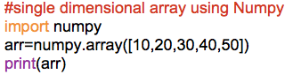

op:



Ex2: Create a 2D Array and perform some matrix mathematical operations.

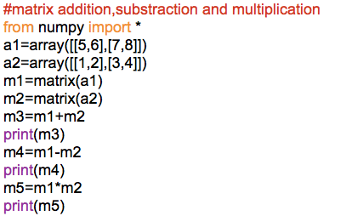

op:

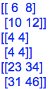

**Command Line Arguments:**

- The concept of passing the values from the command prompt at the time of running the python file is known as “Command line arguments”

>python test.py abc xyz pqr

- Python file name is also taken as a one of the command line argument.

- All the command line arguments are stored into a list object in the form of strings and that list object is stored into the “argv” variable of “sys” module.

- sys is a one predefined module

Ex1: Program to understand command line arguments.

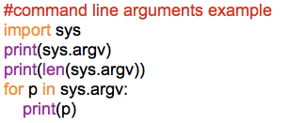

Op:

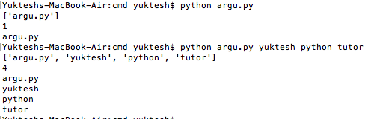

Ex2: Addition operation on command line arguments

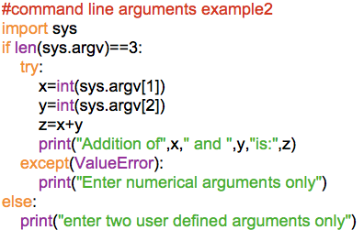

Op:

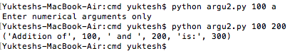

**Main Module(__main__):**

-Which python file directly we are running that python file we call as main module.

- The name of the current module is stored in 1 predefined attribute called

__name__

Ex1: demo.py

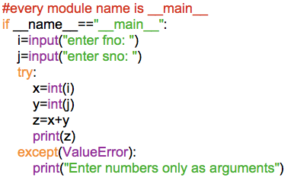

op:

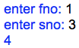

Some variables in SYS Module are

1. Python software version check using sys



1. Copyright information of python software

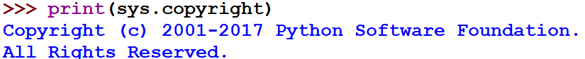

1. Python software installed location

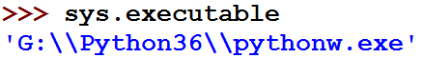

1. Built-in module names in the system directory

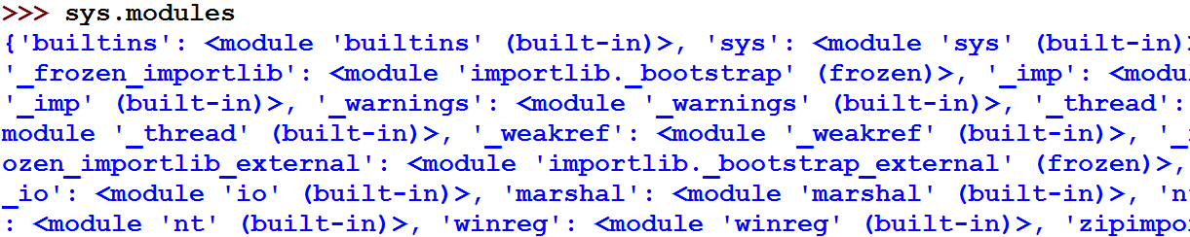

**OS Module:**

OS is a predefined module and which provides various functions and methods to perform the operating system related activities such as creating the files, removing the files, creating the directories, removing the directories and execute the operating system related commands etc.

os.getcwd() gives current working directory

os.chdir() helps in changing the directory

os.pardir gives parent directory

Ex: Working with os module

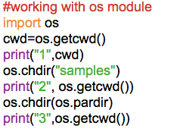

Op:

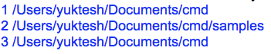

os.listdir() gives all the files and folders available in this directory

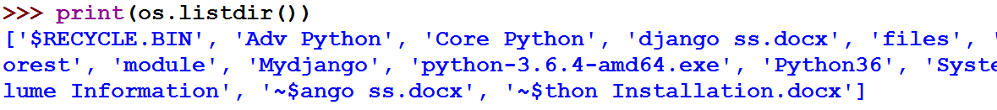

-There are 2 ways in which we can make a directory. Creating two directories with “myfolder1” and “myfolder2” in those 2 ways.

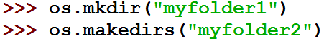

makedirs() helps in creating many internal directories in 1 step where mkdir() cannot create internal directories.

-There are 2 ways we can remove directory, showing this with an example.

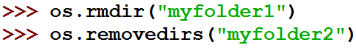

removedirs() helps in removing internal directories also, whereas rmdir() will remove only 1 directory

-To rename a file or folder.

